Project “Regional policies for innovation driven competitiveness and growth of rural SMEs – INNOGROW”
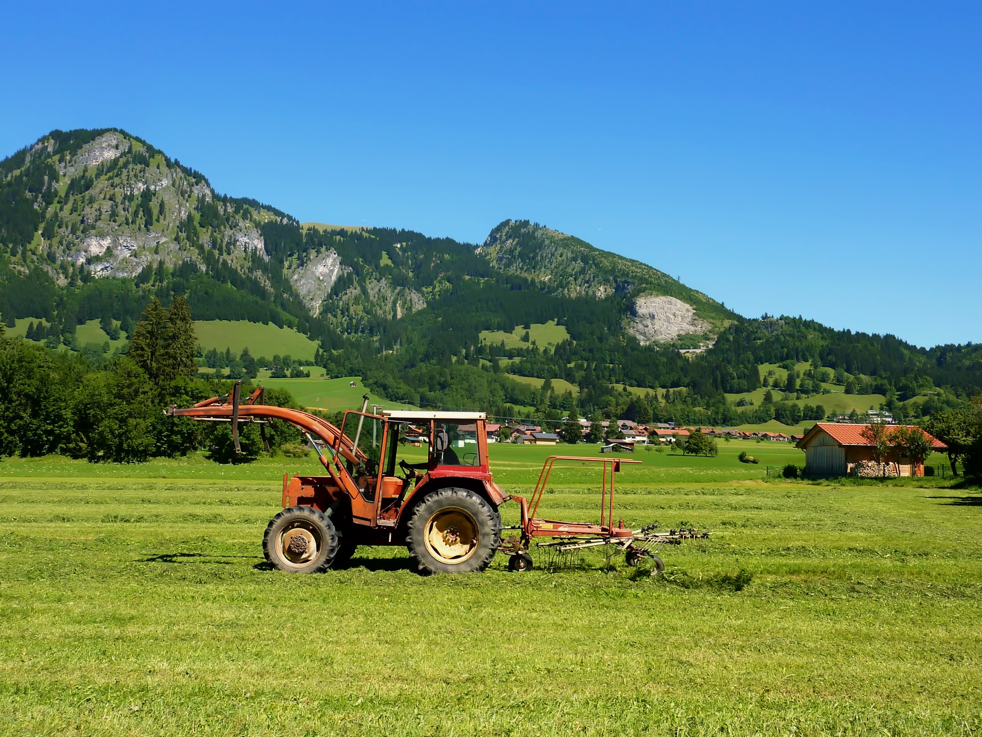
Activity A2.2 “Public Consultation Meetings”, Activity A2.2 output Synthesis report on common issues, barriers & enablers for innovation diffusion

2018

A2.2 “Synthesis report on common issues, barriers & enablers for innovation diffusion”. This report has been prepared within the Project “Regional policies for innovation driven competitiveness and growth of rural SMEs – INNOGROW”, Activity A2.2 “Public Consultation Meetings”.
This report only reflects the author's views and that the programme authorities are not liable for any use that may be made of the information contained therein.

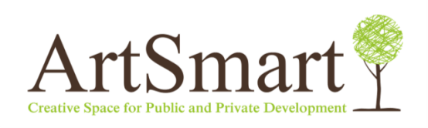
Consortium of SAFEGE Baltija ltd and ArtSmart ltd
Authors: Inga Uvarova, Alise Vītola, Iveta Baltiņa

March, 2018
Responsibility for the content and presentation of findings and recommendations rest with SAFEGE Baltija and ArtSmart team.

Cover photo provided by the INTERREG Europe programme.

Contents
Introduction 5
1. The methodology 7
1.1. Public consultation meetings 7
1.2. Synthesis report 10
2. Rural economy and the characteristics of the project regions 12
2.1. Theoretical context of rural economy and rural SMEs 12
2.2. Characteristics of the project regions 16
3. Barriers and challenges of the rural SMEs 20
3.1. Theoretical aspects of obstacles faced by rural SMEs 20
3.2. Consultations with stakeholders of partners regions 22
3.3. Highlights from the interviews 24
3.4. Summary on main barriers and challenges 26
4. Development opportunities for rural SMEs 29
4.1. Theoretical aspects of opportunities and influencing factors 29
4.2. Consultations with the stakeholders of the partners’ regions 47
4.3. Highlights from the interviews 57
4.4. Summary on development opportunities 59
5. SWOT analysis 63
6. Policy recommendations 64
6.1. HERE AND NOW 65
6.2. COMING SOON and ON THE HORIZON 74
7. Bibliography 80
8. Annexes 87
Annex 1: Persons interviewed and questions of the interviews 87
Annex 2: Detailed contents of each public consultation meeting 89
Annex 3: Main economic data of the partner regions 94
Annex 4: Urban-rural typology for NUTS level 3 regions 95
Annex 5: Characteristics of the INNOGROW regions (EDORA typology) 96
Annex 6: New technologies suitable for rural economy SMEs 98
Annex 7: Types of new business models (indicative list) 99

Abbreviations
B2B – Business to business
BM – Business model
BMI – Business model innovation
EAFRD – European Agriculture Fund for Rural Development
EEA – European Economic Area
ERDF – European Regional Development Fund
EU – European Union
EU-28 – 28 European Union member states
GDP – Gross domestic product
IFC – International Finance Corporation
ICT – Information and communication technologies
INNOGROW – Project “Regional policies for innovation driven competitiveness and growth of rural SMEs – INNOGROW”
IoT – Internet of Things
IP – Intellectual property
ltd – Limited liability company
OECD – Organisation for Economic Co-operation and Developmen
OP – Operational Programme
PPP – Public – Private Partnership
R&D – Research and Development
RDP - Rural Development Programme
ROA – Return on Assets
ROI – Return on Investments
ROP – Regional Operational Programme
SIP - Slovenian Industrial Policy 2014-2020
SME – Small and medium entrepreneurs
ToC – Theory of Change
TOP - Territorial and Settlement Development Operational Programme of Hungary 2014-2020
VET – Vocational education and training
24/7 – 24 hours per day and 7 days per week

Introduction
The Interreg Europe project "Regional policies for innovation driven competitiveness and growth of rural SMEs – INNOGROW" (INNOGROW) aims to improve partners' policies on competitiveness of rural SMEs with regard to the integration of new production technologies and business models that lead to innovative products.
This document was produced within the activity A2.2 “Public Consultation Meetings” of the INNOGROW project. The activity A2.2 aims at co-shaping the future allowing for diffusion of innovations that alter existing business models and social habits, thus improving rural economy’s propensity to innovate.
The project partners conducted public consultation meetings of stakeholders with vested interests in rural economy, e.g., rural SMEs, public authorities, NGOs, business associations, research and education organisations, members of general public.
The aim of the public consultation meetings was to build consensus and ensure support by a broader regional audience with regard to the promotion of innovations in the rural SMEs, which operate in rural areas, contribute to the GDP of rural areas, and are related with rural-specific activities. Relevant industries include agriculture, forestry, animal husbandry, aquaculture, manufacturing of food products, beverages, tobacco products, handicraft of local products, agro-tourism, energy and resources, entertainment, recreation and other SMEs operating in rural areas.
There were guidelines developed providing common general principles for all public consultation meetings. The public consultation meetings were organised in seven partner regions and in total 215 different stakeholders were consulted during these meetings. Public consultation meetings were held from November 2016 till October 2017. Participants of the public consultation meetings represented local entrepreneurs, municipalities, public regional bodies, national policy making bodies, higher education and research institutions, non-governmental organisations and business professionals.
Public consultation meetings were started with an introductory presentation about INNOGROW project and clarification of types of innovations and new business models of rural SMEs. Then the stakeholders’ discussions were continued about good examples, barriers and opportunities for local SMEs. The meetings were finalised with an evaluation of the most appropriate types of innovative technologies and new business models identified within other INNOGROW activities (in particular, activities A1.1 “Investigating innovative technologies’ impact on rural economy SMEs’ competitiveness and productivity” and A1.2 “Identifying successful new business models for rural economy SMEs”).
This synthesis report summarises the results of the public consultation meetings organised in the partner regions highlighting common issues, barriers and facilitators of the innovation in rural economies. It also assumes the results of the INNOGROW activities A1.1, A1.2 and A1.4 “Investigating the factors that influence rural SMEs to adopt innovation”.
Based on analysis, policy recommendations are proposed for the project partners’ Local Action Plans to provide incentives for the local rural SMEs to adopt innovative technologies and new business models. The recommendations are tailored to take into account challenges and specifics of partner regions.

The methodology

Public consultation meetings
The public consultation meetings were organised according to the “General principles for all public consultation meetings” produced in August 2016 within the activity A2.2 “Public Consultation Meetings” of INNOGROW project (Zemgale planning region, 2016).
These meetings took place from November 2016 until March 2017. In total 215 participants in seven regions were involved (Table #1): 16 persons attended public consultation meeting in Lombardia (Italy), 22 persons in Molise (Italy), 30 persons in Pardubice region (Czech Republic), 31 person in Zemgale (Latvia), 34 persons in Gorenjska (Slovenia) and 41 person in Stara Zagora (Bulgaria). The average number of participants reached 31 person per meeting.
Table#1. Public consultation meetings in the INNOGROW partner regions
Project partner | Country | Region | Date | Number of participants
1. Lombardy Foundation for the Environment, FLA | Italy | Lombardia | 26.01.2017. | 16
2. Chamber of Commerce of Molise | Italy | Molise | 24.03.2017. | 22
3. Pannon Novum | Hungary | Nyugat-Dunantul | 27.10.2017. | 41
4. Zemgale planning region | Latvia | Zamgale | 25.11.2016. | 31
5. Regional Development Agency of the Pardubice Region | Czech Republic | Pardubice region | 09.02.2017. | 30
6. Regional Development Agency of Gorenjska, BSC Business Support Centre L.t.d., Kranj | Slovenia | Gorenjska | 17.03.2017. | 34
7. Stara Zagora Regional Economic Development Agency | Bulgaria | Stara Zagora | 19.01.2017. | 41
 | Total |  |  | 215
Source: prepared by the authors based on the information provided by INNOGROW partners
Participants of the public consultation meetings represented local businesses from the following sectors: agriculture, forestry, animal husbandry and fishery, manufacturing of food products and beverages, agro-tourism, entertainment and recreation, energy and resources, other rural specific activities; public institutions, incl., municipalities, regions, regional development agencies, ministries; universities and research centres; non-governmental organisations and business consultants.
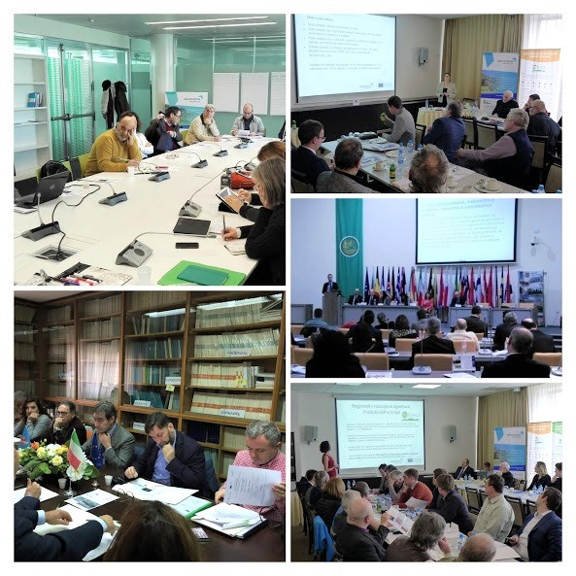
According to the “General principles for all public consultation meetings”, public consultation meetings focused on innovative technologies, successful new business models and their impact on rural SMEs, as well as on factors that induce/hinder rural SMEs to adopt innovations (Zemgale planning region, 2016).
Pic.#1. photos from the public consultation meetings.
Source: archives of INNOGROW partners

Some of the public consultations were merged with other events in order to ensure wider participation of different stakeholders. For example, in Zemgale (Latvia) the public consultations were merged with the event honouring the best entrepreneurs in the region (Zemgale planning region, 2017). In Stara Zagora (Bulgaria) the public consultations were a part of an event focusing on the Investment plan for Europe and innovation (Stara Zagora Regional Economic Development Agency, 2017).
The introductory part of the public consultation meetings included presentations on various topics, important for the rural SMEs, including presentations on available innovation support measures (e.g. regional operational programmes financed by the ERDF, rural development programmes financed by the EAFRD, and the LEADER programme) and presentations of regional best practises in introducing innovative business models, employing innovative production technologies and transferring scientific knowledge into agricultural practice. The best practises presented within the public consultation meetings included:
- Oca Sforzesca S.r.l, a private company from Italy introduced an innovative business model in producing traditional goose products with the 100% goose meat and using a specially developed computerised system based on the iCloud technology (Lombardy Foundation for the Environment, FLA, 2017);
- MyAgry (a web platform), an innovative start-up from Italy allowed anyone interested to become a farmer, remotely "renting" portions of lands for the cultivation of vegetables (Chamber of Commerce of Molise, 2017);
- Karamelu darbnica, ltd., SME and start-up from Latvia produces caramels and has diversified its business model with additional services, creative design and eco products (Zemgale planning region, 2017);
- Farm Līgo from Latvia introduced innovative technologies in producing hybrid cucumber seeds (Zemgale planning region, 2017);
- EK Auce ltd. from Latvia introduced several process innovations in their business model for manufacturing of the clothing (Zemgale planning region, 2017).
Presentations were followed by discussions covering the questions outlined in the “General principles for all public consultation meetings”. Some of the project partners also asked the public consultation meeting participants to vote for the 3 most appropriate types of technological innovations and the 3 most appropriate types of new business models to be applied within rural SMEs.
The detailed content of each public consultation meeting is described in Annex 2 of this report.

Synthesis report
This synthesis report is based on the summary reports of public consultation meetings provided by the project partners. It systemises and summarises conclusions on common issues, barriers and enablers for innovation in rural SMEs discussed within each public consultation meeting. Accordingly the policy recommendations are developed on the base of the discussions of public consultation meetings and summary reports provided.
Picture #2 illustrates the sources of information investigated during preparation of this report.

Pic.#2. Flowchart of the Sources of information investigated.
Source: prepared by the authors
In order to provide a wider perspective, the available results of the INNOGROW activities A1.1 “Investigating innovative technologies’ impact on rural economy SMEs’ competitiveness and productivity”, A1.2 ““Methodology to collect and exchange cases of new business models for rural economy SMEs & corresponding dataset” and A1.4 “Investigating the factors that influence rural SMEs to adopt innovation” were explored in developing this report. The activities A1.1 and A1.2 defined the types of innovative technologies and new business models that can be adopted within rural SMEs. Then these types of innovations and business models where discussed within the Public consultation meetings, assessing the most appropriate types for each partner region and providing good examples from local SMEs. Results of the activity 1.4 were considered during the analysis of barriers and opportunities of rural SMEs relevant to adoption of the innovations (Picture #3).

Pic.#3. links of thiis report with other INNOGROW activities
Source: prepared by the authors

Moreover, three semi-structured interviews were conducted in the written form. Persons interviewed represent partner institutions responsible for the respective INNOGROW activities A1.1, A1.2 and A1.4. The aim of interviews was to shape the conclusions included in this report and to ensure better links of this research with key results of other INNOGROW activities. Persons interviewed and questions of interviews are listed in the Annex 1.
Qualitative and quantitative research methods were used: desk research, semi-structured interviews, logical structure and matrix analysis, flowcharts and statistical analysis (Picture #4). Data from the INNOGROW project, Eurostat and other previous studies were used. The SWOT analysis summaries key external and internal influencing factors identified. The theory of change reflects the relationship between the expected inputs and outcomes in order to facilitate the desired changes.
Pic.#4. Research methods.
Source: prepared by the authors

Further report is structured as follows: the third section of the report outlines the specific characteristics of the project regions, based on the latest quantitative data from the Eurostat and typologies used by the European Union and previous studies focused on the rural economy; the fourth section summarises main obstacles and risks for the introduction of innovative technologies and new business models in rural SMEs; the fourth section focuses on the opportunities and factors that facilitate introduction of innovative technologies and new business models in rural SMEs; the fifth section within the SWOT analysis summarises all factors influencing adoption of innovations and new business models within rural SMEs; the sixth section proposes policy recommendations to provide incentives for the local rural SMEs to adopt innovations. The recommendations take into account regional conditions, challenges and specifics of partners’ territories.

Rural economy and the characteristics of the project regions

Theoretical context of rural economy and rural SMEs
Rural SMEs and the rural economy are often discussed among various stakeholders and researchers. As the INNOGROW project aims at improving partners' policies to foster competitiveness of rural SMEs, the term “rural SMEs” or “SMEs in rural areas” must be explained in more detail.
According to the EU legislation, small and medium enterprises (SMEs) are companies with less than 250 employees, with the annual turnover up to 50 million euro or with a balance sheet total up to 43 million euro. SMEs are classified as medium-sized, small and micro enterprises. Medium-sized enterprises have 50-249 employees, the annual turnover does not exceed 50 million euro or a balance sheet total does not exceed 43 million euro. Small enterprises have 10-49 employees, the annual turnover does not exceed 10 million euro or a balance sheet total does not exceed 10 million. Micro enterprises have less than 10 employees, the annual turnover does not exceed 2 million euro or a balance sheet total does not exceed 2 million euro (European Commission, 2003).
The SMEs are the backbone of European economy, they constitute 99.8% of enterprises which operate in the EU-28. SMEs employ 93 million people, accounting for 67% of the total employment in the EU-28 and generate 57 % of value added in the EU-28. 93% of the European SMEs are micro enterprises, that employ less than 10 persons, 5,8% of the European SMEs are small enterprises, that employ 10-49 employees. Only 0,9% of SMEs are medium enterprises, that employ more than 50 employees (European Commission, 2017a).

Table#2. CONTRIBUTION OF THE EUROPEAN SMES TO THE ECONOMY
Contribution area | EU-28 | Czech Republic | Greece | Italy | Latvia | Hungary | Bulgaria | Slovenia
Employment, % | 66.6 | 66.8 | 86.9 | 78.6 | 79.0 | 68.5 | 75.2 | 73.3
Value added, % | 56.8 | 54.5 | 75.7 | 67.7 | 69.8 | 52.9 | 66.7 | 64.0
Source: European Commission (2017a)
With particular relevance to the Member States represented in the INNOGROW project, the share of SMEs in terms of employment and value added is very high in Greece, where SMEs provide 86.9% of the employment and 75.7% of value added, and in Latvia, where SMEs provide 79.0% of the employment and 69.8% of value added. The values are lower for Italy, Bulgaria and Slovenia, but still higher than the EU-28 average indicators. Out of the countries involved in the INNOGROW partnership, the contribution of SMEs to the economy is the lowest in Czech Republic and Hungary. In Czech Republic SMEs provide only 66.8% of the employment and 54.5% of value added; in Hungary - 68.5% of the employment and 52.9% of value added (Table #2).
As the INNOGROW project focuses specifically on rural SMEs, the definition of the term “rural area at the EU level” should be made. The EU urban-rural typology classifies regions based on the share of population living in rural areas (areas where the population density is below 150 inhabitants per km²). This typology is used in all European Commission communications, reports and publications concerning regional development (Eurostat, 2017). According to this methodology, NUTS3 regions of the EU member states are classified in three categories: predominantly urban regions, where the share of population living in rural areas is below 15 %; intermediate regions, where the share of population living in rural areas is between 15 % and 50 %; and predominantly rural regions, where the share of population living in rural areas is higher than 50 % (Eurostat, 2017).
According to the EU urban-rural typology, most of the regions represented in the project are predominantly rural regions, where rural population is at least 50% of inhabitants. Exceptions are Pardubice, Stara Zagora and Gorenjska, which are classified as intermediate with rural population between 20% and 50% of total population. Some parts of (Karditsa and Trikala), Nyugat-Dunantul (Zala) and Lombardia (Sondrio) are also classified as intermediate regions. Moreover, several parts of Lombardia are classified as predominantly urban regions with rural population falling below 20% of total population - Varese, Como, Lecco, Milano, Bergamo and Brescia (Annex 4 and 5).
Thus, a rural SME can be defined as a company with less than 250 employees and with an annual turnover up to 50 million euro or with a balance sheet total up to 43 million euro, which operates in a region where more than 50 % of inhabitants live in an area with a population density below 150 inhabitants per km².
Furthermore, one thing should be clear; when there is a dispute about the notion of rural SMEs, it does not mean only agricultural enterprises, but all business sectors or industries represented in the rural areas (Picture #5).
Pic.#5. Groups of rural smes to be approached by INNOGROW.
Source: prepared by the authors
Therefore the meaning of the term “rural economy” shall be explained. There are different approaches how various stakeholders treat this concept. In the narrow context, the rural economy is explained by the structure of economic sectors and industries present in rural areas that ensure jobs and deliver services or products. In this context it is important to understand if the rural economy of the particular region is dominated by the agriculture and to what extent other non-agriculture business sectors are represented, for instance tourism, manufacturing, energy, food production and other (Kruszilicika et al, 2014, Ionela et al, 2015, Tarasovych, 2017).
In terms of economic sectors represented, rural regions in Europe have undergone significant changes in recent decades. The role of traditional rural industries, such as farming, forestry and fishery, mining and quarrying, as well as manufacturing of food and wood products, is declining (Cowie et al, 2013, Fieldsen, 2013). Although agriculture still accounts for a significant proportion of the employment in remote rural areas, rural economies move away from traditional rural sectors towards more knowledge intensive sectors and the service economy (Cowie et al, 2013). Thus, the rural economies now have a greater need for globally-oriented, entrepreneurial ﬁrms than before (Galloway, 2007). If the rural regions can successfully adapt to this transformation through job creation in a broad mix of industry sectors, then they can avoid the decline by building the ‘new rural economy’. Moreover, rural regions have a multifunctional role in sustainability over and above their economic activity, for example, as a space for recreation and tourism, as well as providers of ‘ecosystem services’ such as biodiversity and climate change mitigation (Fieldsen, 2013).
Moreover the rural economy enables the discussion about the socio economic development aspects of rural and remote areas. Researchers highlight that rural areas are characterised by the comparatively high share of small enterprises, mainly producing for their own consumption. This is regarded as an obstacle for the successful development of rural areas as these economic subjects are not productive and are more reluctant to innovations and diversification of economic activities. Consequently this results in the lower productivity rate of SMEs, amount of foreign investments, GDP and the income of the population (Cimdina, 2014, Kruszilicika et al, 2014, Ionela et al, 2015, Tarasovych, 2017).
Rural regions have a multifunctional role in sustainability over and above their economic activity, for example, as a space for recreation and tourism, as well as providers of ‘ecosystem services’ such as biodiversity and climate change mitigation (Fieldsen, 2013).

Characteristics of the project regions
Specific characteristics of the regions should be taken into account while making conclusions on common issues, barriers and enablers for innovation diffusion in rural SMSs and developing policy recommendations. While the project partners have an in-depth knowledge of their territories, an outlook of the regional economy reveals some similarities and differences among the partner regions (Annex 3).
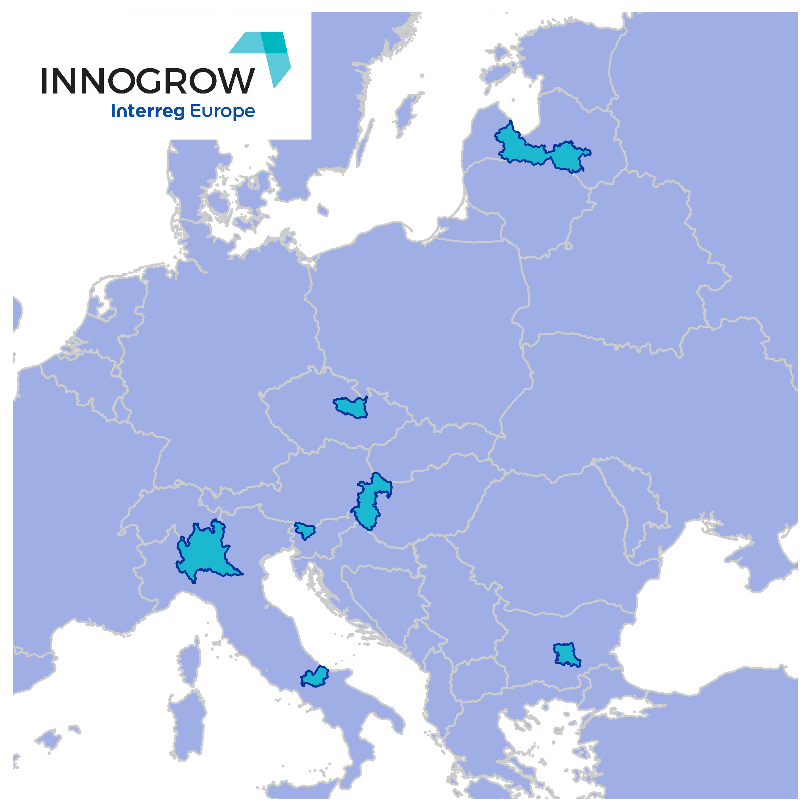

Pic.#6. PARTNER REGIONS of INNOGROW PROJECT
Source: prepared by the authors
For the INNOGROW project, we propose to classify the project regions (Picture #6) according to the structure of the regional economy by using 2 criteria: the share of agriculture and the share of manufacturing in the region’s economy. This methodology allows for dividing the partner regions in three distinct groups:
- Agricultural regions with a high share of the primary (agrarian) sector in the economy and a medium or low share of the secondary (manufacturing) sector – Zemgale (Latvia) and Thessalia (Greece);
- Diversified regions with an important secondary (manufacturing) sector and medium or low share of the primary (agricultural) sector – Pardubice region (Czech Republic), Nyugat-Dunantul (Hungary) and Gorenjska (Slovenia);
- Regions with a highly developed tertiary (service) sector and medium or low share of primary (agrarian) and secondary (manufacturing) sector – Stara Zagora (Bulgaria), Molise (Italy) and Lombardia (Italy).
The matrix (Table #3) illustrates the structure of the economy in the partner regions.

Table#3. Matrix of the economic Structure of the INNOGROW regions
 |  | Share of agriculture (NACE A)
 |  | High | Medium | Low
Share of manufacturing  (NACE C) | High | - | Pardubice region (CZ)  Nyugat-Dunantul (HU) | Gorenjska (SI)
Share of manufacturing  (NACE C) | Medium | Zemgale (LV) | Stara Zagora (BG) | Lombardia (IT)
Share of manufacturing  (NACE C) | Low | Thessalia (EL) | Molise (IT) | -
Source: prepared by the authors based on Eurostat (2017)
A similar typology has been developed in the ESPON applied research „EDORA – European Development Opportunities for Rural Areas” (ESPON & UHI Millennium Institute, 2013). This methodology is known as “the EDORA cube” and is widely used in regional research. It involves a three dimensional framework for analysis, assessing such aspects as the rurality/accessibility, the degree of economic restructuring and the socio-economic performance of the region (Annex 5).
Firstly, EU urban-rural typology divides regions in 3 categories: predominantly urban regions (less than 15% of inhabitants live in rural areas), intermediate regions (from 15% to 50% of inhabitants live in rural areas) and predominantly rural regions (more than 50% of their population live in rural areas). In addition, each of these 3 categories are divided into accessible regions and remote regions. A region is considered to be accessible, if more than half of its residents can drive to the centre of a city of at least 50 000 inhabitants within 45 minutes.
Zemgale, Molise and parts of Thessalia (Karditsa and Trikala), Nyugat-Dunantul (Zala) and Lombardia (Sondrio) are classified as predominantly rural regions, from which Zemgale is a predominantly rural accessible region, whereas Molise region and parts of Thessalia (Karditsa and Trikala), Nyugat-Dunantul (Zala) and Lombardia (Sondrio) and predominantly rural remote regions. In contrast, Pardubice, Stara Zagora and Gorenjska, as well as parts of Thessalia (Larisa and Magnisia), Nyugat-Dunantul (Győr-Moson-Sopron and Vas) and Lombardia (Pavia, Lodi, Cremona and Mantova) are intermediate accessible regions.
Secondly, non-urban region structural typology divides regions in 4 categories: agrarian regions with a high share of gross value added and share of employment in primary sector; consumption countryside with a high capacity for and intensity of tourism activity, access to natural areas and the importance of peri-productivist (not technologically intensive, but multifunctional) farming; diversified regions (secondary sector) with a strong manufacturing sector and diversified regions (market services) with a strong private service sector.
In terms of non-urban region structural typology, Zemgale, Thessalia (except from Magnisia region) and Zala from Nyugat-Dunantul region are characterised as agrarian economies with a strong primary sector. Lombardia (except from Sondrio), Pardubice region, Nyugat-Dunantul (except from Zala) and Campobasso from Molise region are classified as diversified non-urban regions with strong manufacturing or private service sector. Finally, Stara Zagora, Gorenjska, Isernia from Molise and Sondrio from Lombardia are considered as consumption countryside – non-urban regions with well-developed tourism and recreation sector, as well as with an important presence of peri-productivist farming.
Thirdly, regional performance typology illustrates the overall socioeconomic development trends of the region. It classifies regions into depleting, below average, above average and accumulating, according to their placement compared to the EU-27 average level in such indicators as migration, GDP per capita, change in GDP, change in total employment and the unemployment rate. Regional performance assessment shows that the regional human and financial resources are accumulating only in two region – Lodi and Mantova in Lombardia. The regional performance in other parts of Lombardia, Isernia in Molise, Gorenjska, large part of Nyugat-Dunantul (Győr-Moson-Sopron and Zala) and in parts of Thessalia (Karditsa, Magnisia) is above average, showing that these territories have more positive development tendencies than the EU27 rural regions on average. In contrast, in other parts of Thessalia (Larisa, Trikala), Pardubice, Vas in Nyugat-Dunantul and Campobasso in Molise the regional performance is below average. Furthermore, in Zemgale and Stara Zagora the regional performance is way below the average EU27 indicators, indicating that the human and financial resources in these regions are depleting. Generally, the diversified non-urban regions and the consumption countryside regions perform better and, according to the research, and likely to continue to “accumulate” in the immediate future.

Barriers and challenges of the rural SMEs
During the public consultation meetings participants discussed the main barriers and challenges the rural SMEs face in relation to the introduction of innovative technologies and new business models. The project experts, responsible for the implementation of INNOGROW activities A1.1, A1.2 and A1.4, were also interviewed. This section reveals the overall theoretical dispute of theorists and researchers, as well as the results of discussions and consultations executed within INNOGROW project.

Theoretical aspects of obstacles faced by rural SMEs
The policymakers have recognised a need for an enterprising countryside with sustainable agriculture and environment, as well as thriving and inclusive rural communities (Smallbone et al, 2003). Therefore it is important to identify the challenges that rural SMEs face due to their remote location and propose solutions accordingly.
A limited scale and scope of local market, as well as a high distance from major national and international markets is one of the competitive disadvantages faced by the rural SMEs (Kubickova et al, 2017, Smallbone et al, 2003, Smallbone and North, 1999). Therefore rural SMEs should be particularly active in seeking external markets and improving their marketing strategies to reach their clients (Smallbone and North, 1999). Focusing on niche products is another way to overcome this challenge (Smallbone et al, 2003). Furthermore, nowadays information and communication technologies (ICT) allow reaching customers or business partners all over the world. Internet might be used for trading, brand building, advertising and marketing, as well as business networking (Galloway, 2007).
Lack of innovative spirit, especially amongst companies in ‘traditional’ rural sectors, is another challenge faced by the rural SMEs (Fieldsen, 2013). The reasons for establishing a business in rural regions often differ, compared to cities, with rural regions having a larger share of “lifestyle” rather than “entrepreneurial” firms (Galloway, 2007). Moreover, many of the rural SMEs see their mission in not only providing profit, but also fulfilling wider socioeconomic goals, such as maintaining the traditional lifestyle, landscape quality and wildlife, as well as safeguarding the archaeological and historic features of the territory (Tate, 2010).
Furthermore, as the population in rural regions is often ageing faster than in urban areas, there is a concern about the business succession, especially in more traditional rural sectors as agriculture and manufacturing due to the lack of potential takeover managers. Furthermore, the loss of young people in the rural regions reduces the local “dynamic” (Fieldsen, 2013, Lopez and Pastor, 2015).
Limited opportunities to attract workforce on the one hand, and relatively low wage levels and high employee loyalty on the other hand reduce incentives to invest in technologies, especially in more craft-based sectors (Kubickova et al, 2017, Fieldsen, 2013, Smallbone and North, 1999). In contrast, those SMEs that choose to invest in technologies point to the mismatch between the job offers and the qualification of locally-available labour force manifesting as a shortage of skilled labour (Fieldsen, 2013).
Rural SMEs have a lower probability to outsource and cooperate, compared to their urban counterparts, as other companies, R&D facilities, educational institutions and business support providers (accountants, law firms etc.) are located further away (Smallbone et al 2003, Smallbone and North, 1999)
Access to suitable training is typically more difficult for rural SMEs, as low population density inevitably makes it difficult to create a critical mass for providing training. As a result, rural SMEs have lower level of knowledge and skills, including technological, management and ICT knowledge and skills. Moreover, often training is not adjusted to the needs of local businesses and labour market (Fieldsen, 2013, Smallbone and North, 1999). Also business support services are less accessible for rural SMEs, compared to their urban counterparts, and often do not comply with their actual needs (Fieldsen, 2013).
Furthermore, rural SMEs tend to be smaller as average companies and have a higher proportion of microbusinesses and one-person businesses. Thus rural SMEs are likely to be less able to meet their development needs from their own internal resources (Smallbone et al, 2003, Smallbone and North, 1999). Also shortage in infrastructure, administrative barriers and unfavourable taxes hamper the growth of SMEs in rural regions (Kubickova et al, 2017, Fieldsen, 2013).

Consultations with stakeholders of partners regions
In the public consultation meeting in Lombardia, Italy, the stakeholders outlined several obstacles for the introduction of innovations and new competitive business models within the rural SMEs, namely, the lack of innovation culture and the bureaucratic/ administrative burden. In addition, the stakeholders pointed to the risks of the lack of territorial coordination, extreme fragmentation of the innovation promotion initiatives, as well as lack of continuity in policies and measures supporting innovation (Lombardy Foundation for the Environment, FLA, 2017).
In the public consultation meeting in Molise, Italy, the speakers and stakeholders highlighted that profitability is the key aspect for the sustainability of SMEs. However, for rural SMEs profitability cannot be the only sustainability aspect and must necessarily be accompanied with other functions such as social, environmental and cultural. Also such deficiencies as a fragile economy and insufficient investment in infrastructure were mentioned (Chamber of Commerce of Molise, 2017).
The stakeholders at the public consultation meeting in Nyugat-Dunantul, Hungary, outlined several obstacles and risks for the introduction of innovations and new competitive business models within the rural SMEs: lack of innovation culture and lack of support for introducing innovations in rural SMEs. The participants also mentioned several drawbacks, namely short duration of the calls in the innovation support programmes, lack of permanent support for introducing innovations, lack of coordination of the consulting support, as well as bureaucracy (Pannon Novum, 2017).
In the public consultation meeting in Zemgale, Latvia, the stakeholders stressed difficulties in hiring new skilled workforce, which is crucial for introducing innovations. This problem is especially severe in rural regions close to the capital city Riga, like Zemgale, where the lack of skilled workforce, as well as a high employee turnover impedes the growth of rural SMEs. Also, the difficulties to compete on a global level were mentioned, as the prices of resources are rising. Last but not least, the stakeholders pointed to the lack of innovation culture and insufficient cooperation between science, business and the public sector (Zemgale planning region, 2017).
The stakeholders at the public consultation meeting in Pardubice region, Czech Republic, emphasized the lack of subsidies for accessibility, infrastructure, sustainable mobility and smart grids in rural areas. They also raised the question of high administrative burden and slow process of examining proposals to product improvements. The participants expressed a wish to improve their knowledge and skills to apply for innovation support programmes, to obtain subsidies and to establish cooperation with scientific institutions, thus indicating insufficient knowledge with relation to the above-mentioned topics (Regional Development Agency of the Pardubice Region, 2017).
The participants of the public consultation meeting in Gorenjska, Slovenia, which was focused on new technologies and business models in cheese and dairy production, outlined the insufficient cooperation between farms due to lack of trust and underdeveloped cooperation culture. An important issue, which was raised in Gorenjska, was the multi-functionality of rural farms, as they not only produce, but also contribute to landscape, biodiversity and the quality of life. However, farms are not being properly compensated for providing these additional functions. Participants of the public consultation meeting also stressed the lack of knowledge and skills within the companies, as farmers often do not have time to participate in training or even look for learning opportunities, especially in the planting and harvest season. Stakeholders also pointed to the limited capacity of rural SMEs to negotiate a fair price for their products with large retail chains and franchise brands, as they have to compete with big corporations, which are able to dedicate a lot of funding to advertisement (Regional Development Agency of Gorenjska, BSC Business Support Centre L.t.d., Kranj, 2017).
In the public consultation meeting in Stara Zagora, Bulgaria, stakeholders emphasized the lack of adequate policies to support adoption of innovation in rural SMEs and the large amount of administrative burden in the innovation supporting programmes. Again, the lack of highly qualified and skilled staff in the rural areas was mentioned as an important problem impeding the growth of rural SMEs. The lack of information exchange on best-case examples and innovation development opportunities within rural SMEs was highlighted (Stara Zagora Regional Economic Development Agency, 2017).

Highlights from the interviews
Matthew Gorton represents the University of Newcastle upon Tyne (United Kingdom), the main responsible partner for the implementation of INNOGRROW Activity A1.1. He was asked to reflect on the key findings of Activity A1.1. Matthew Gorton was asked to mention the main problems and challenges that hinder introduction of innovations within rural SMEs.
First, Matthew Gorton mentioned that rural SMEs tend to employ local workforce, which is limitted comparing to the urban areas. Thus, rural SMEs lack the workforce, especially highly qualified employees, which are essential for development of innovative technologies.
Second, introduction of innovative technologies requires comparatively large investments. Rural SMEs lack their own funding and have insufficient possibilities to attract external funding, as confirmed by Matthew Gorton.
Missing or underdeveloped infrastructure of information communication technologies (ICT) is the third important problem for rural SMEs, that was named by Matthew Gorton. Innovations often are related to ICT, including the use of different “smart tools” and other “Internet of Things” (IoT) opportunities. SMEs are limited in that respect comparing to urban areas and metropolitan areas where ICT infrastructure is more developed.
As considered by Matthew Gordon, these problems lead to the limited business diversification opportunities, which is the fourth most important challenge for rural SMEs.
Similarly, Giuseppe Cutillo representing the Chamber of Commerce of Molise (Italy) was asked to specify main problems and challenges that the rural SMEs face in relation to introduction of the innovations. This organization is the main responsible partner for INNOGROW activity A1.4, in which the survey was performed to identify the main factors that influence rural SMEs to adopt innovations.
According to Giuseppe Cutillo, the key results of the survey show that most SMEs lack financial resources necessary for the development and adoption of technological innovations. There are high technology integration costs required for the adoption of innovations. Rural SMEs have considerable difficulties and insufficient capacity to attract public and private funding to cover such integration costs.
Moreover, as stated by Giuseppe Cutillo, the rural SMEs lack the expertise and skills essential for adoption of technological innovations. Existing employees are not qualified enough and rural SMEs are unable to hire new employees with relevant skills and a qualification. Furthermore, rural SMEs have lack of the appropriate external advisers related to the high technology integration costs and, in general, adoption of innovations.
Giuseppe Cutillo also indicated that the rural SMEs have comparatively small demand for products from customers and other related stakeholders. Rural SMEs often focus their sales exclusively to the local market, meaning - to the customers within the local residence area of particular SME. SMEs are not using full potential of development opportunities for sales to wider foreign markets.
Venelin Dobrev, who represents the Stara Zagora Regional Economic Development Agency, Bulgaria, the main responsible partner for INNOGRROW Activity A1.2., was asked to indicate the main problems and challenges that hinder introduction of new business models within rural SMEs.
According to Venelin Dobrev, the main challenges that SMEs face in introducing new business models are related to skills, knowledge and information available for rural SMEs. There is a weak capacity inside SMEs themselves and insufficient number of business advisers or experts for rural SMEs that would help them to introduce and implement new business models. Moreover, many rural SMEs are not familiar with the current and latest innovations that they can adapt into their business model and they are not exchanging good practices between themselves as well. This highlights the underused possibilities of the networking among rural SMEs and in a wider scale to exchange the knowledge and an experience on common topics.
Venelin Dobrev shares the opinion of both other interviewees about the financial capacity of rural SMEs, which is the hindering factor in relation to adoption of new business models. In most cases an introduction of new business models requires financial investments in the new equipment, staff, software and marketing of the new products or services. Venelin Dobrev commented that usually rural SMEs do not have necessary funding available from internal sources. They have to attract external private or public funding which is not so easy for them to obtain.
Venelin Dobrev added one more important aspect related to the personal ambitions and goals of rural entrepreneurs. A lot of managers or owners of rural SMEs do not realise the need to change their business model and adapt to the rapidly changing market conditions. Rural entrepreneurs are more familiar with the process and benefits of adoption of new technologies. The common way of thinking is that the implementation of new technology will give better financial results for the business. However, most of the rural SMEs do not think about process innovations in terms of marketing, logistics, collaboration with other enterprises and other forms of new business models.
Summing up, three interviewees mostly acknowledged the same problems and challenges that hinder adoption of innovations and new business models within rural SMEs. Firstl, the main barriers the rural SMEs face are related to the insufficient financial capacity and skills, knowledge and workforce available for the adoption of innovations and new business models. These factors can be categorised as mainly external factors. Second, the rural SMEs lack personal ambitions and ability to use full potential of networking and cooperation, diversification of products and services, and acquiring new customers or wider (foreign) sales markets. These factors can be categorised as mainly internal.

Summary on main barriers and challenges
The main barriers and challenges that the rural SMEs face can be classified into five groups (see Picture #7).
Pic.#7. Barriers and challenges of the rural SMEs for the introduction of innovative technologies and new business models.
Source: prepared by the authors

Shortcomings in the environment for innovation include the lack of innovation culture and low interest in innovative solutions. Large part of rural SMEs do not realise the need to change their business model and adapt to the rapidly changing market conditions. As a result, the business demand for innovation does not fulfil its potential.
On the other hand, participants of public consultation meetings stressed that the interactions between business, science and the public sector is not close enough, impeding the development and commercialisation of innovation. Businesses should be more active in demanding innovative solutions from the scientists. The scientists should focus more on the needs of the users instead of technical solutions of the problems, which might not be economically sustainable for everyday use in rural SMEs.
Several participants of the public consultation meetings stressed the fragmentation and discontinuity of innovation policies and support measures. Public institutions often lack the competence to build efficient innovation programmes for rural SMEs. Therefore, innovation support measures should be designed in a close cooperation with the industry, adapting to the real needs of businesses. Another challenge is the development of rural SMEs that are not agricultural companies, as the rural development programmes largely focus on the agriculture sector. Administrative burden within the innovation support measures was also often mentioned as an important drawback.
Another barrier for the innovations in rural SMEs comes from the lack of knowledge and skills within the companies. Rural SMEs lack information and knowledge on the use of innovative solutions, which they can adapt into their business model. The number of business advisers and experts for the rural SMEs is insufficient and the exchange of good practices between rural SMEs is poor. Moreover, farmers and other small business owners often lack time to look for education opportunities and participate in training, especially if seminars and consultations are organised in periods when farmers are busy working in the field. Business advisers of rural SMEs should inform and motivate farmers to attend information events and training. An important barrier for the innovation in rural SMEs is also the missing ICT skills for the older generation, which impedes their SMEs getting relevant information and data, as well as hinders use of new technologies.
In most cases the introduction of innovative solutions requires financial investments in new equipment, staff, software and/or marketing. Usually such funding is not available from internal sources, thus rural SMEs have to look for external private or public funding. Unfortunately, often rural SMEs lack a general knowledge on funding instruments, including the support measures and alternative funding options, such as business angels, venture capital funds, crowdfunding platforms and etc.
An important challenge for the rural SMEs is difficulties in hiring new skilled workforce, as innovative solutions require employees with relevant knowledge and skills. The lack of highly qualified staff in the countryside, as well as high turnover of employees in the rural areas close to the cities was mentioned as one of the most important problems, that hindersadoption of innovation.
Another challenge that was raised is the attraction of young people to rural areas, as they often do not see rural business as an appealing alternative to the city life.
Many participants of the public consultation meetings mentioned the insufficient capacity to compete as a barrier for the introduction of innovative technologies and new business models. In some areas the high competition causes rural SMEs to focus on low prices instead of quality improvements. In comparison to big corporations, rural SMEs are not able to invest much in advertising their high-quality products. Moreover, rural SMEs have a limited capacity to negotiate a fair price for their products with the large retail chains and franchise brands. Therefore, many small producers focus on direct sales, which limits their market expansion possibilities. Participants also mentioned the pressure of raising wages and resource costs, which make it more and more difficult to compete internationally, as other countries support local producers more actively and have lower administrative burden for businesses.
Other barriers and challenges for the introduction of innovative technologies and new business models in rural SMEs, that were mentioned by the participants of public consultation meetings and experts, included limited business diversification, fragile economy and insufficient investment in infrastructure, low-quality ICT infrastructure, lack of territorial coordination of investments, long period of economic return on investment, inappropriate health care system and short growing season.

Development opportunities for rural SMEs

Theoretical aspects of opportunities and influencing factors
Elements of the competitiveness and a business model
Policy makers and researchers have discussions about the advantages and opportunities of rural SMEs to increase their competitiveness through adoption of innovations and new business models.
The level of the competitiveness show how enterprises “manage the totality of their competences and resources to achieve long-term prosperity” (IMD, 2017, Garelli, 2006). Competences and resources include a number of factors (Picture #8) that facilitate or hinder the development of innovations. They all together may influence the particular strategy and business model used by the enterprise for increasing the competitiveness.

Pic.#8. FACTORS INFLUENCING the competitiveness.
Source: prepared by the authors
Comparatively large part of researchers considers that rural SMEs are economically inefficient, unable to introduce innovations and thus with a low competitiveness. However there are theorists that are certain that the potential of innovations and new business models in rural SMEs is not fully utilised (Cimdina, 2014, Cowie et al, 2013).
Smart Specialisation is one of the key priorities to strengthen innovations within the regions of EU. Smart specialisation strategies form the base for prioritising and allocation of EU funds for R&D and innovation activities. Smart specialisation strategies are striving to boost innovation – led growth of regions of EU, assuming not just technologically driven innovations, but taking a broader view on innovations (Arnoe & Cavallaro, 2016, S3 Platform, EC [s.a]). The EU regions identify skills, competences, resources, technologies and other advantages for using all opportunities of the potential of innovations (European Commission, 2017b). New technologies are more often associated with innovations and play a crucial role in raising the competitiveness of SMEs. However, in the wider context of innovations a number of process innovations, social innovations and other differentiation of activities may enable the adoption of new business models within SMEs.
There are a number of definitions of a business model (Picture #9). The business model covers several aspects related to the business. First, scholars and practitioners highlight the value proposition, which is based on detailed understanding of the customer segments and their specific needs or problems. Secondly, the revenue generating approach and streams that are related to the envisaged relationship with customers, sales channels and methods for the delivery of products to customers. Last, but not least, the process of production of products or services, associated costs and a partnership that facilitate business activities (Teece, 2010, Osterwalder and Pigneur, 2010, Schon, 2012, Teece, 2018).
Teece (2018) highlighted that a successful business model may help an entrepreneur to understand customer needs and provide an appropriate solution to those needs assuming the right balance between the production costs and revenues in order to generate satisfactory profit.

Pic.#9. New or improved Business models.
Source: prepared by the authors
Practitioners and investors see scalable business models as successful, meaning that a particular business can be easily multiplied or replicated within various locations, markets or customer segments.
A business model is not customised just via the technological aspects, but the strategic approach. A good business model shall envisage aspects how to differ from competitors of the same industry, for instance, different target customer segments and the value proposition.
On the other hand, not just competitors push entrepreneurs to introduce new business models. Entrepreneurs are constantly seeking for possibilities to improve efficiency and profitability. Customers may require a higher quality of the products thus leading to adoption of new business models.
Opportunities and influencing factors
Often new business models are initiated by technological development. The “Industry 4.0” digitalisation possibilities integrate physical and digital technologies for improving the business performance and processes. Internet and digital technologies enable a number of new business models of large scale in parallel with complementary niche business models. The Industry 4.0 technologies may open new ways for building relationship with the customers, suppliers, employees or partners. Digital technologies may enable new logistic channels, improve production process and other aspects of the business model (Delloite, 2018, Teece, 2018). Artificial intelligence, Internet of Things (IoT), cloud technologies and on-line systems for management of processes are some of the possibilities that provide solutions to the problems identified in the previous sections of this report.
Diversification of business activities of rural farms and other traditional SMEs can open possibilities for introduction of new business models. There are a number of advantages identified bringing further opportunities for SMEs operating in rural areas.
Multifunctional agriculture envisages diversification of agricultural production via introduction of other complementary activities. While the agriculture is kept as the primary economic resource within the agricultural farm, other business activities that may use the same agricultural resources are introduced, for instance, bio-energy, tourism, educational activities, cultural services and other (Lanfranchi and Giannetto, 2014). Educational farms and holiday farms can be provided as examples. Educational farms may offer different services related to the development of skills and knowledge for their customers. Holiday farms may offer therapy, relaxation and leisure in authentic or natural rural space for various types of customers (Lanfranchi and Giannetto, 2014).
Rural and agro-tourism have to be specifically emphasized as an important opportunity for rural SMEs. Rural tourism is associated with tourism services and attractions in the rural areas using local resources, often related to local natural and historical heritage. Agro-tourism forms a part of rural tourism and is related to tourism visits to farms and other agricultural enterprises, that demonstrate agricultural methods and approaches used and provide tasting of products produced or exploiting other local resources for entertaining tourists within the particular agricultural enterprise (Ionela et al 2015, Cimdina, 2014). The rural areas are important tourism destinations for so called green or slow tourism, which is contrary to touring trips to “all inclusive” destinations. The nature in combination with self-experiencing and visiting local farms, crafts and producers are demanded tourist entertainments and attractions in “slow tourism” destinations (Zawadzka, 2017).
Researcher Cimdina provides an example from Latvia, where the owner of the agricultural farm has diversified his business by introducing new services and products related to the rural bath-house. The idea of a bath-house by itself is not an innovation, but already well-known historical tradition in Latvia. However, new services and products introduced form a new business model for the farm. On the basis of historical bath-house traditions, the farm provides bath-house rituals for busy and tired business people. This farm has opened a school of bath-house and organises various seminars. Moreover, it produces different bath-house related natural products from the resources gained within the farm. This entrepreneur successfully introduced a new business model, which later overgrew the initial agricultural business division in this farm (Cimdina, 2014). More detailed analysis on this business case can be found in the reference article of Cimdina (2014).
Social farming occurres when the enterprises besides the profitability goals aim at performing some social functions. Social functions can be related to the involvement of vulnerable or disadvantaged groups, preventing depopulation in remote rural areas or by other means contributing to the improvement of the quality of life in the local society (Lanfranchi and Giannetto, 2014). The remote rural areas are geographically under-served thus bearing risks for local people to fall out of the labour market and become disadvantaged. Rural SMEs provide work opportunities for the local people thus ensuring their involvement into the labour market. The challenge for rural SMEs is the lack of workforce and a limited choice of employees among the local people living in the rural area. Thus rural SMEs are forced to attract various socially disadvantaged employees, such as people with disabilities, older people in the pre-retirement and retirement age, and others. While in the short-term this provides a possibility to attract the support under the social business support initiatives, in the long-term there is a number of advantages related to the diversity management of workforce regardless of their gender, nationality, age, educational and social background, and other differences. The diversity management improves employees’ motivation, customer satisfaction and the company's reputation. The diverse workforce is able to understand better the variety of customers and the market, generate new ideas and maintain the productivity (Sumedrea, 2017, Wondrak and Segert, 2015, Tisserant, 2013, Darnell and Gadiesh, 2013, Hanappi-Egger, 2012).
The restaurant “Manu Guru” in Lithuania can be provided as an example. Besides the ordinary restaurant business, this company performs social functions. Manu Guru has introduced the Social Reintegration Programme for people that have started rehabilitation from the addictions. This company provides employment opportunities and other social benefits for former drug addicts to encourage their rehabilitation process, for instance, consultations of psychologist, mentoring and assistance in beginning of new life without addictions, providing non-formal education, helping to gain professional experience and find further job opportunities. While company takes care of social integration of particularly vulnerable group of the society, they also solve the problem of the lack of workforce. This company is awarded and recognised by the European Commission as one of the good examples of a social enterprise (Mano Guru, [s.a]).
Another good example is “Kingdom of rabbits” in Latvia, which also performs social goals besides the agricultural and tourism business activities. It works with the former prisoners and provides to these people employment opportunities and assistance in beginning of new life (Kingdom of Rabbits [s.a.]).
The opportunity of local and agro food producers as well as the craftsmen is the focus on the niche market of local authentic products. Rural SMEs have a potential in this niche because of the availability of local specific material and non-material resources, as well as the preserved historical production traditions (Cei et al, 2017, Arnoe & Cavallaro, 2016). Positive aspects of these entrepreneurs are seen in more environmentally-friendly business processes. However often these producers target comparatively small markets, which limits further development and growth. In order to develop successfully two aspects are important. First, the innovative value proposition for the customer, meaning that the entrepreneur shall sell not just a product, but a specific legend or a story behind the product that creates new values and needs for customers to purchase it. Second, it is important to form a pool of local producers and craftsmen thus collaborating instead of competing, which is described in further chapters.
Autine Tools Company ltd from Latvia can be provided as an example. Autine has specialised in the production of the exclusive, high quality axe and cutting-tool crafting by hand (Picture #10). They produce kitchen knives, hunter knives and axes. Through continuing century-old crafting traditions and combining them with modern, Northern European design, Autine creates handmade items using the wisdom of ancient crafting techniques and methods. Moreover, the company has been named after the Autine castle of the 12th century and several of their products have names related to the Latvian history and mythology (Autine, [s.a.]).


Pic.#10. Carpenters Hatchet and a set of damascus chef knives By Autine Tools Company, LV
Source: archives of Autine Tools Company
Autine is a small workshop that provides full production process until a ready-made and packed instrument. Their team consist of several bladesmiths accompanied with a carpenter and a leather crafter. Products are sold on Autine Internet shop and knivesandtools.co.uk. Autine collaborates with distributors in the Netherlands, South Africa, Germany and are developing collaborations with Sweden, China and Japan. Autine uses Facebook, Twitter and Instagram to promote their products. They also take part in professional events, trade shows and exhibitions abroad. Each instrument comes with a lifetime warranty, which covers all possible manufacturing defects. The prices range is from 220 to 1950 euro per piece/set. The average waiting time for an item is 6 months. Autine was founded by two brothers Janis un Matiss Nimanis, and their sister Karline. Janis is responsible for the production, Matiss for the public relations and Karline for logistics and book-keeping. Forging at first was Janis hobby that gradually turned into a family business. Autine is selling its products all over the world, mostly to North America, Western and Northern Europe, but also to Asia and Australia. They have received numerous awards, e.g. Australia’s largest 4x4 magazine “4x4 Adventures” have named their Hunters and Bushman axes as the best in the world (Autine, [s.a.]).
Marketing of rural areas by shaping the image of these areas and residents. Rural areas are characterised by a large number of small enterprises that by alone most often are not able to carry out significant marketing and communication activities and thus reach larger markets. Instead, branding of a particular rural area and forming its image as a “thematic village” or other “common local identities” with its unique features, advantages and resources available would be an opportunity (Tarasovych and Tamuliene, 2017). Branding and positioning of a particular area is not a new concept, however this practice is not widely applied within rural areas and still has unused potential. Local or regional authorities or other local action groups of civil society members shall take the leading initiative in such marketing activities. When creating a new image or brand of such “thematic villages” the specialisation of the particular area has to be considered based on local attractions, specific production, natural, spatial, demographic, historical, cultural and other resources (Ceapraz, Delhoume, 2017, Tarasovych and Tamuliene, 2017, Zawadzka, 2017).
The bioeconomy development process goes in line with the development of rural areas and SMEs operating there. It is one of the development areas under the Smart Specialisation and is an important development priority of the EU. Also globally acting international organisations, such as the OECD, IFC and United Nations pay attention to this discipline. The definition of the bioeconomy has moved forward from the initial context related to the biology and biotechnologies. Now it is perceived by environmental, sustainability, technological, economic and social aspects. European Commission (2017c) defined the bioeconomy as “the production of renewable biological resources and the conversion of these resources and waste streams into value-added products, such as food, feed, bio-based products as well as bio-energy". European Commission adopted the Bioeconomy Strategy, which aims to ensure food security, sustainable management of natural resources, reduction of dependence on non-renewable resources, mitigation to climate change, creation of jobs and maintaining EU competitiveness (European Commission, 2017c).
The bioeconomy is shaping rural areas towards environmentally friendly and sustainable growth thus it is particularly important regarding the further competitiveness of rural SMEs. Entrepreneurs need to combine knowledge and technologies in order to produce environmentally friendly, eco-efficient and competitive products. Bioecenomy is related to a wide range of sectors – agriculture, forestry, fishing and aquaculture, energy, transport, medicine, production of food, cosmetics, chemicals and other industrial goods that use biomass and renewable biological resources. Regarding the bioeconomy, common opportunities of rural SMEs may cover the production and distribution of agricultural products, production of safe and well-balanced food, reduction of waste and greenhouse gas emissions and other (Adamowicz, 2017, Miceikiene, 2017).
Discussion about the bioeconomy leads to the concept of circular economy, which stands for the sustainable development through minimising the generation of waste and more efficient (less) use of natural resources (raw materials and energy). In order to meet the competitiveness aims, the business sector is trying to expand in the global market and increase consumption of products produced. On the opposite, the circular economy represents the ecological principles in order to reduce the dependence on fossil fuels, improve the management of natural resources and treat the climate change issues. The circular economy is seeking for solutions how to transform the environmental challenges in further business opportunities and trying to find a balance with the growing consumption needs. The circular economy promotes development of new business models, eco innovations and technologies that extend the product life and produce more durable products, as well recycling or repair and reuse of the resources. Entrepreneurs are seeking the business models that are economically justified and feasible. The motivation for a business to apply such eco innovations and new business models is seen in the possibility to increase the efficiency, reduce costs and potential risks, improve the quality of products in such gaining the competitive advantages. Moreover, eco innovations and new technologies shall enable new approaches for optimised management of productions process and logistics (Zhelyazkova, 2017, Costea-Dunarintu, 2016, Bonciu, 2014).
Both the bioeconomy and circular economy encourages development and adoption of eco innovations. The rural SME Sybimar LLC from Finland is an example - it has introduced a new business model and eco innovations responding to the bioeconomy and the circular economy concepts. This enterprise combines the food and energy production into a unit where nutrients, water, waste, heat and CO² are recycled back to the energy and food production (Picture #11).

Pic.#11. example of the business model with a closed circulation cycle and “0” waste production.
Source: archives of Sybimar LLC.
Sybimar has a number of diverse business activities. It has introduced the closed circulation and “zero” waste production approach. It produces bioenergy, which ensures the heat for the fish farm and the greenhouse. Fish are grown in the indoor pools using the closed cycle water recirculation system that ensures water for planting herbs in greenhouses. Moreover, this company produces biofuel from the leftovers and waste of a fish and a biomass. Most of the fish breeding processes in the fish farm are controlled and managed by an on-line management system. This system improves the efficiency, as it requires less employees and allows the management and control of the processes on-line from the distance in 24/7 mode (Sybimar, [s.a.]).
Another example is the farm “Ligo” from Latvia, which was presented in the Public Consultation meeting in Zemgale region (LV). This farm has 3 main business divisions – grain crop planting, biogas production and greenhouses (Picture #12).

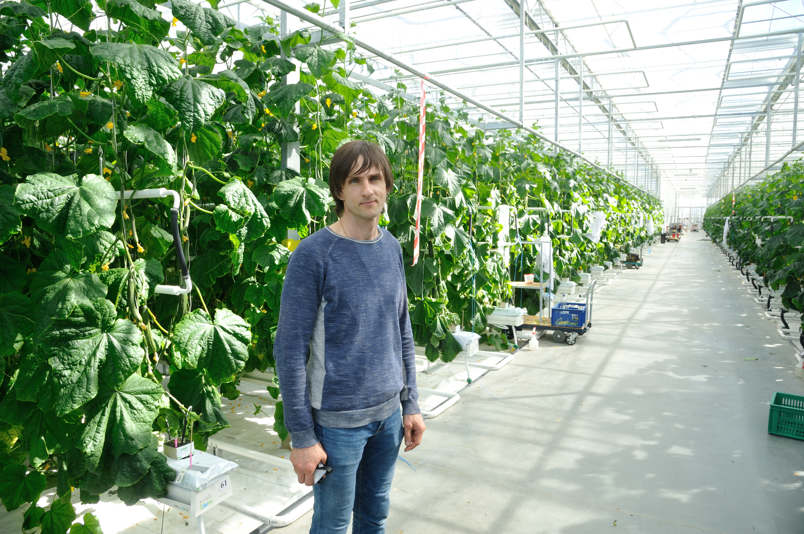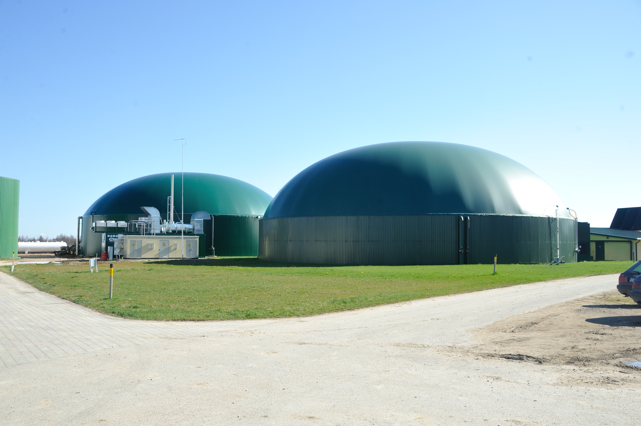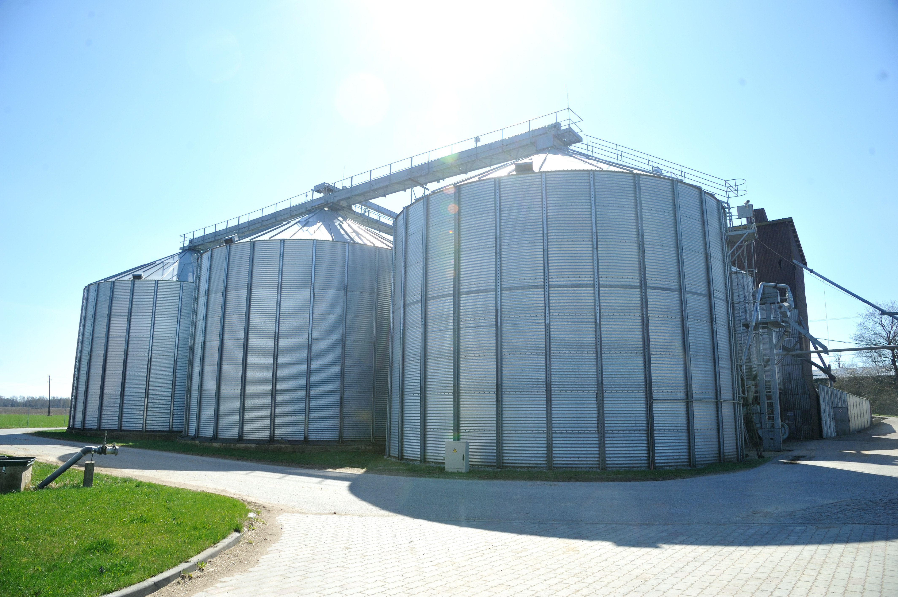
Pic.#12. PICTURES FROM FARM “LIGO”, LV
Source: photos made by Subhankulovs T. (Latvijas Avize, 2016)
This entrepreneur gradually has developed his farm by growing the capacity (size) and diversifying business activities. After the establishment of the farm, first business division was the grain crop planting. This business sector composes significant risks related to the prices and demand of the grain stock market. Therefore the entrepreneur decided to diversify the business with higher value added activities. Firstly, he constructed the biogas station, which produces heat for greenhouses. The corn, planted in this farm, is the main biomass resource for the biogas station. Now this entrepreneur is seeking for diversification options and testing specific beets with higher energy intensity to be used as the biomass resource. This would allow increasing the efficiency and productivity. Secondly, the entrepreneur constructed greenhouses where he is planting cucumbers. The main products of the greenhouses are the seeds of cucumbers that are sold to the global multinational agricultural and agro-chemical production company. Even though he has one stable global B2B customer, the entrepreneur diversified the business by planting spinach and asparagus for other market segments. The owner of the farm “Ligo” plans adoption of new technologies in comparatively near future – drone technologies for monitoring and control of plants and self-driving tractors (Latvijas avīze, 2017).
Sharing economy as a recently significantly expanding concept provides opportunities and can influence as well rural SMEs. Scholars name it as peer-to-peer economy, mesh economy, collaborative economy or collaborative consumption. The sharing economy is based on the idea that one having assets (both material and non-material) that are not used in a full capacity may share these assets with others willing and being able to use them within a limited period of time. An important side of the sharing economy is the social networking and technologies that provide these collaboration opportunities. Digital technologies through online platforms ensure access to networking and partnering on a global scale, putting together demand and supply sides. The business model of sharing economy is based on the possibility to obtain, give and share access to products or services without owing them (Bonciu and Balgar, 2016, Privitera, 2016, Szetela and Mentel, 2016, PWC, 2015).
Introduction of the sharing economy activities in the business model may improve the efficiency of resource use. Resources or assets that are unused or partly used can be traded, exchanged or shared. Sharing economy also introduces new forms of safety and trust with the reviewing system for both a person willing to share and a person using shared products. These reviews provide an assessment and characteristics of the reliability and reputation on both sides. Online platforms used by the sharing economy business models provide new dissemination and sales promotion opportunities on a global scale (Privitera, 2016, Bonciu and Balgar, 2016, Szetela and Mentel, 2016).
Sharing economy opens new ways of horizontal and vertical partnerships in the virtual and real marketplace and expands to a number of industries and business sectors. A number of these sectors are represented and related to the rural SMEs, for instance, hospitality and dining, transport and courier, retail, media, advertising, arts, entertainment, education and learning, funding and other services (PWC, 2015, JustPark.com [s.a.]).
Practical examples how rural SMEs may use the sharing economy facilities are listed below:
- Rural SMEs can use platforms for selling their services or products, for instance, tourism and hospitality services, vegetables and other food products, products produced by craftsmen.
- Rural SMEs can co-share use of professional services, for instance, logistic services for delivery products or for the supply of materials, outsourcing of packaging services, renting of storage facilities and other.
- A possibility to interact and communicate with a wider target group, to disseminate the information about the products or services, new products launched and get immediate feedback from the customers.
- A possibility to virtually involve the potential customers or partners in the development of new products or services.
- A possibility for the attraction of funding through peer-to–peer lending or crowdfunding platforms, which may provide alternative funding opportunities to commercial banks and public support programmes.
- Learn new skills and knowledge by using virtual study groups, on-line courses and lectures. Implementation and adoption of new business models require an appropriate capacity of an enterprise and its management.
Development of strong and dynamic managerial capabilities to see and explore new opportunities due to the changing market conditions is essential for entrepreneurs. Moreover, not just being proactive in developing new business models, but more importantly - being able to implement them by rearranging business processes and assigning resources. Learning and knowledge sharing shall be encouraged, as rural SMEs are reluctant to innovations and changes (Teece, 2018, Singh and Bhowmick, 2015, Lopez and Pastor, 2015).
Knowledge/knowhow sharing is also possible through co-creating or co-working spaces. Innovation labs, hubs and other co-working spaces encourage researchers, entrepreneurs, public authorities and any citizen to work together in creating and testing new products or services. People using the same facilities of hubs or labs are forming new internal or external networks that embolden for new visions and an innovation processes in general. On already established partnership bases, new projects can be started more easier, risks of development new technologies or projects can be shared (Felicetti, 2016, Szetela and Mentel, 2016, EPC, [s.a]).
The discussion on the business models more and more encourage SMEs to think about possible forms of a collaboration and partners that may facilitate the business and improve the competitiveness. In a simple form of a business model, the suppliers of materials and other resources are considered. However there are other new forms and aims of partnering among SMEs. Several SMEs can work together to improve the distribution channels and logistics, as well as work more effectively with distribution networks, retail chains or other larger customers. SMEs can create the partnership to attract highly qualified employees or, in general, work together on the solutions for lack of workforce. SMEs can work together on development of innovations dealing with the productivity and value propositions issues. Besides to the B2B commercial partnership in the narrow meaning, the broader multi-stakeholder partnership is important. However, it is not easy for SMEs to build, manage and scale up such partnerships. Besides the access to technology transfer, new technologies or other innovations, the multi-stakeholder partnership may facilitate access to larger clients, wider customer segment and financing (Connect to Grow, 2016).
Lately different public initiatives encourage establishment of the partnership between SMEs and investors in different investment brokering or so called “speed-dating” events, as well as partnerships between innovative entrepreneurs in different matchmaking events and mentoring programmes. However these initiatives are more focused on the entrepreneurs with higher profitability potential more often located in urban or metropolitan areas. There is still a potential to develop such initiatives specifically towards rural SMEs assuming more social impacts generated to particular rural areas than profitability aspects.
EK Auce ltd from Latvia can be mentioned as a good example in adopting several innovations and changes in the business model. This enterprise is located in the rural area of Zemgale region (LV), near the border with Lithuania (approx. 120 km far from the capital Riga). EK Auce is manufacturing textile clothing (Picture #13 and Table #4). Representatives of EK Auce participated in the public consultation meeting of Zemgale region (LV) and presented their practice in developing new business models.
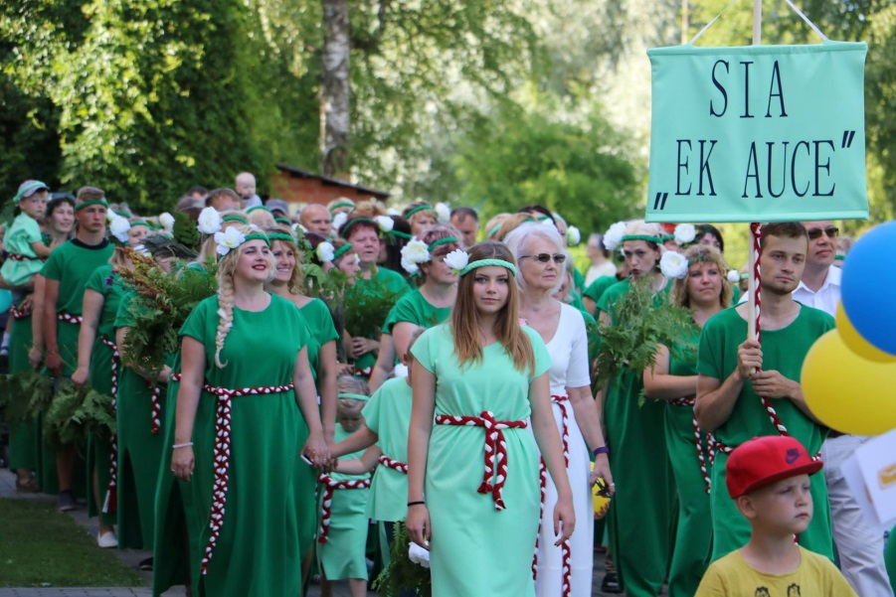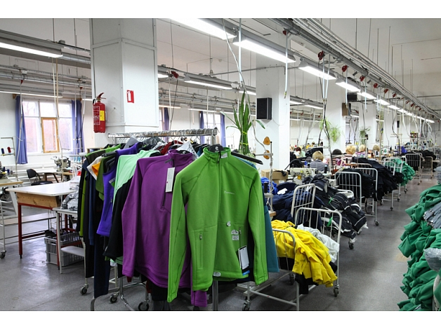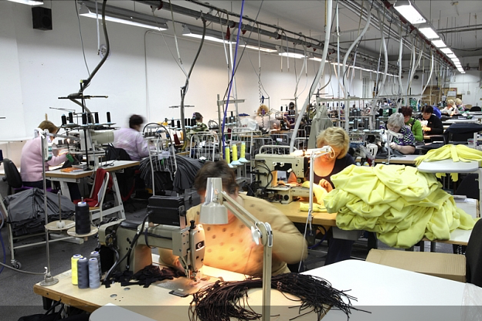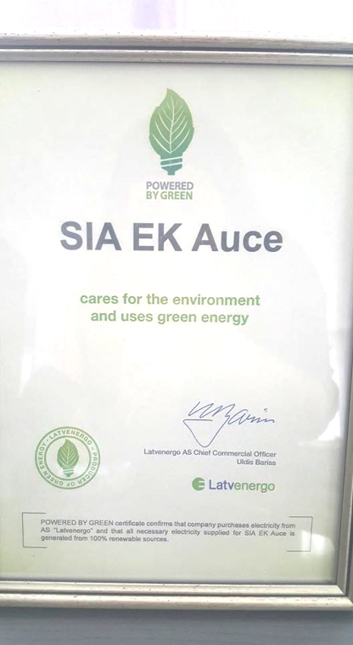
Pic.#13. PICTURES OF EK Auce ltd., LV
Source: archives of EK Auce ltd.
EK Auce was seeking for the solutions to the problems faced due to the changing market conditions. Most of these solutions have brought changes into the business model. Due to the economic instability of the local market, EK Auce has aimed at the international markets. Through the intense work the B2B customers were found within the international markets. Currently EK Auce exports their products to a number of countries, incl., Canada, USA, Sweden, Norway, Korea, Japan, UK, Switzerland, Germany, Denmark and other western Europe countries. However, now EK Auce faces problems related to the lack of workforce.

Table#4. EK Auce in applying new business models in the manufacturing of textile clothing (in Zemgale region, LV)
Problem/ situation | Changes in existing BM applied | Business model aspects
Need for new customers segments and launching new services | The customers of EK Auce are multinational/ global companies. EK Auce produces sports wear for globally known companies/ brands. | New B2C customer segments abroad in international markets.
Sales to multinational/ globally known companies/ brands increased causing the insufficient production capacity | EK Auce contracted outsourced sewers to ensure larger capacity.  In order to follow quality requirements of large customers, EK Auce trained outsourced sewers | Partnership - a pull of local sewers and sewing companies
Outsourced partners lack the appropriate equipment and technologies | Outsourced sewers had limited possibilities to take a loan in the bank for purchasing new equipment.  EK Auce purchased and installed new equipment for outsourced sewers.  EK Auce took all the financial liabilities on behalf of the outsourced sewers and provided them with a possibility to pay back in a longer period through regular instalments this amount of funding | New forms of financing and partnership
Lack of employees and thus insufficient production capacity | EK Auce attracted as employees persons with disabilities. In order to adapt to the needs of persons with disabilities EK Auce introduced:  - Smart work principles (persons with disabilities can work from home), employees have specifically assigned tasks to be able to work from home,  - Flexible work schedule adapted to the specific needs of each person with disabilities.x | Diversity management and “smart work” initiatives
Source: prepared by the authors based on the information of the Zemgale planning region (2017)

The theory of the social capital justifies the importance of the partnership. Many scholars have provided definitions for this concept. Some of them have proved the positive relation between the social capital and the development of innovations and rural areas (Ceapraz and Delhoume, 2017, Jankova et al, 2017, Zawadzka, 2017). The social capital can be defined as the social networking and collaboration between various actors for productive use and aiming at the common goals. It means that every individual involved is actively participating in common social collaboration form. This ensures exchange of practices, skills, competences and information providing the joint knowledge or the new approach. The scholars (Ceapraz and Delhoume, 2017, Jankova et al, 2017) argue that the social capital is becoming as an important base to reach the competitive advantage, because technologies and other physical assets are available to everyone, but the opportunity of the cooperation or networking between particular stakeholders is an individual relationship creating major and unique intangible asset that differentiates from others in the market.
While the surroundings of urban/ metropolitan areas provide natural possibilities for partnership by having a large number of residents (individuals, enterprises, organisations) relatively close to each other, rural areas are under-served because of the physical distance between actors. Therefore, networking and collaboration of different stakeholders of rural areas needs to be encouraged and facilitated.
The start-up "MyAgry" was presented as a good example in the public consultation meeting in Molise region (IT). “MyAgry” is using principles of sharing economy and social capital. It is an on-line platform providing the opportunity to become a virtual farmer and to rent a land from a distance (virtually) for the cultivation of vegetables to anyone (Picture #14). Interested persons register in the on-line profile, select the size of the plot of the land, the crops and the treatment. Then they can follow and monitor on-line from the distance the process of cultivation and harvesting of the crops selected. At the end fresh or processed vegetables are delivered to the particular customer or these customers can directly come to the farm and participate in the harvesting. The platform puts together agricultural farms with customers willing to purchase vegetables directly from producers and personally experience the process of planting the crop (Chamber of Commerce of Molise, 2017).

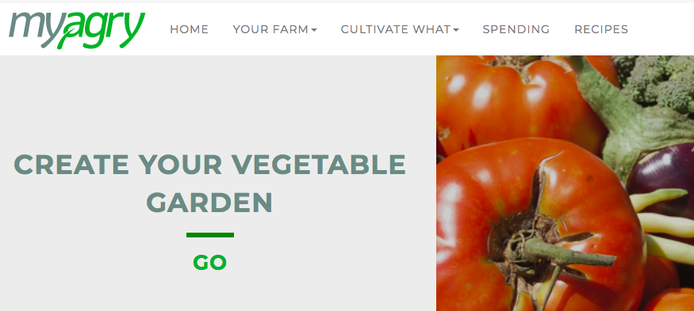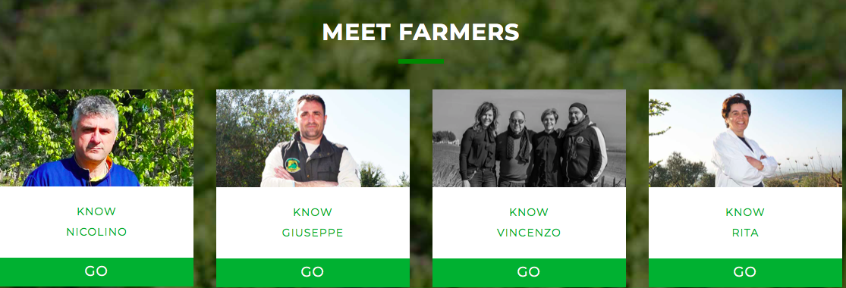
Pic.#14. Screenshots FROM Mygry platform, IT
Source: archives of "MyAgry"
In general, while participating in MyAgry platform, agricultural farms continue their ordinary business activities, but this collaboration introduces a new business model to interact peer-to-peer with the consumers, provides new marketing opportunities and opens access to wider target groups. Besides the need of purchasing fresh vegetables, the value proposition for customers puts together elements of entertainment, gaming and personal experience or involvement in the farming.

Consultations with the stakeholders of the partners’ regions
The participants of the public consultation meeting in Lombardia, Italy, outlined such context factors and opportunities to promote innovations and new competitive business models within rural SMEs as the multifunctionality of rural SMEs, new forms of governance for rural areas and innovation of traditional products. New business opportunities might arise for rural SMEs also from providing services for the local territory and due to the introduction of policy instruments oriented to land planning and environmental protection. Consequently, the stakeholders proposed support measure for the rural SMEs that focus on such areas as the ecosystem services, urban-rural partnerships and improvement in the local governance. Policy instruments were suggested to finance and support innovation in rural SMEs, a platform for innovation of rural districts/supply chains, as well as training programmes (Lombardy Foundation for the Environment, FLA, 2017).
The stakeholders at the public consultation meeting in Molise, Italy, highlighted the necessity to provide more information to those rural SMEs who are interested in the support measures financed by the ERDF and the Rural Development Programme of Molise. The participants argued that it is important to employ a bottom-up approach in rural areas by listening to the area and talking to the workers. According to the stakeholders, new opportunities are provided by the digital communication, which results also in the change of marketing of the products and services produced in the rural areas. Last but not least, the stakeholders proposed to revitalize and give a new value to the Chamber of Commerce of Molise brand "Piacere Molise" in order to promote the products produced in Molise region (Chamber of Commerce of Molise, 2017).
The participants of the public consultation meeting in Nyugat-Dunantul, Hungary, proposed policy instruments to facilitate innovations and new competitive business models within the rural SMEs, incl., the innovation chain to support innovative ideas concerning rural areas, further calls for proposals for the innovative rural SMEs within the ERDF Operational Programme and more innovative aspects in the agricultural logistics programmes financed by the Rural Development Programme. Innovation support programmes should focus on innovative rural SMEs until creating a prototype, supporting biodynamic and organic products, as well as supporting innovative marketing of products. Consultative support should be provided for the innovation chain and the protection of intellectual property (Pannon Novum, 2017).
The stakeholders at the public consultation meeting in Zemgale, Latvia, outlined diversity and a wide variety of products, cooperation between businesses, product visibility, certification, experience, social responsibility and choosing local products and resources as the key factors that promote innovations and new competitive business models within rural SMEs. The participants also pointed to such opportunities as the cooperation of businesses with the municipalities, support for youth initiatives, as well as EU funded support for modernisation of production and energy efficiency. Regarding new policy initiatives, the stakeholders stressed that the state should provide a stable and predictable taxation policy, minimize administrative burden, support activities aimed at targeting of large external markets and help home producers to distribute their production, e.g. by establishing shops for selling these products.
Consequently, the participants proposed policy recommendation aimed at facilitation of innovations and new competitive business models within rural SMEs:
- to promote “triple helix” approach (a more efficient cooperation between businesses, academic and public sector);
- to disseminate more information about new technologies and innovative business models among the rural SMEs;
- to speed up the process of granting support for introducing of new technologies, as the technologies change fast and, until the time of approving the project, better technologies might be already available;
- to simplify the process of granting support for introducing of new technologies, as in many cases the technologies are being tested and adjusted during the process of implementation and therefore it is not possible to provide a very detailed technical description of the technology when submitting the proposal;
- to provide support for selling local products in local and international markets (e.g. support for distributing products in the supermarket chains) (Zemgale planning region, 2017).
Public consultation meeting in Pardubice region, Czech Republic, did not include a discussion on context factors and opportunities to promote innovations and new competitive business models within rural SMEs. Instead the participants voted for the innovative technologies and business models that they considered the most helpful to facilitate the competitiveness of rural SMEs. The results of the voting are discussed in the next chapters (Regional Development Agency of the Pardubice Region, 2017).
The participants of the public consultation meeting in Gorenjska, Slovenia, which focused on new technologies and business models in cheese and dairy production, proposed policy recommendations aimed to facilitate innovations and new competitive business models within rural SMEs: strengthen the cooperation between farms, allowing them to optimize production costs, marketing costs and other costs and reduce taxes for farms playing a multifunctional role, for example, preserving the cultural landscape and contributing to biodiversity, tourism and the quality of life. The stakeholders also stressed that it is crucial to provide rural development counsellors with an access to educational programs and strengthen their role in advising, motivating and enlist farmers in relevant training programmes. Special training programs should be provided for older farmers on the use of modern ICT technologies and the time of training must be adjusted to the calendar of farmers by organising training in the time periods where there is less or no work on the fields (Regional Development Agency of Gorenjska, BSC Business Support Centre L.t.d., Kranj, 2017).
Public consultation meeting in Stara Zagora, Bulgaria, did not include a discussion on the context factors and opportunities to promote innovations and new competitive business models within rural SMEs (Stara Zagora Regional Economic Development Agency, 2017).
INNOGROW project has identified 12 new technologies suitable for rural SMEs within the activity A1.1 “Investigating innovative technologies’ impact on rural economy SMEs’ competitiveness and productivity”.
Three of the project partners (Regional Development Agency of the Pardubice Region, Zemgale region and Lombardy Foundation for the Environment, FLA) asked the participants of the public consultation meetings to vote for the three most appropriate types of technological innovations to be applied within rural SMEs of their region in order to increase their competitiveness. The summary of answers is presented in Table 5.

Table#5. Votes for technological innovations to be applied within rural SMEs
Project partner |  | Zemgale planning region | Regional Development Agency of the Pardubice Region | Lombardy Foundation for the Environment, FLA
Region and country |  | Zemgale, Latvia | Pardubice region, the Czech Republic | Lombardia, Italy
Innovation types |  | TOP choices
Innovative production technologies | Organic farming, biotechnology
Innovative production technologies | Renewable energy
Innovative production technologies | Precision agriculture
Innovative production technologies | Crop resistance systems
Innovative production technologies | Novel crop
Innovative production technologies | Functional foods
Technologies supporting products' distribution | E-platforms for products' promotion
Technologies supporting products' distribution | Online orders and delivery tools
Technologies supporting products' distribution | Food traceability systems as marketing tool
Technologies supporting product's safety | Smart meters and Internet of Things
Technologies supporting product's safety | Internal products traceability systems and traceability as a supply chain management tool
Technologies supporting product's safety | Selective breeding and feeding processes
Source: prepared by the authors based on information of the Zemgale planning region (2017), Regional Development Agency of the Pardubice Region (2017), Lombardy Foundation for the Environment, FLA (2017)
Regarding innovative production technologies, all three regions agreed that organic farming and biotechnology should be applied in SMEs in order to increase the competitiveness. Two of three regions (Zemgale and Pardubice region) included renewable energy as one of the top innovative technologies. Pardubice region also outlined the potential of precision agriculture, and Lombardia – the potential of functional foods as one of the innovative technologies necessary to increase the competitiveness of rural SMEs.
As for the technologies supporting products' distribution, Zemgale and Lombardia regions chose e-platforms for products' promotion, as well as online orders and delivery tools as the most important technologies to increase SMEs competitiveness. Lombardia also voted for food traceability systems as a marketing tool.
Regarding technologies supporting product's safety, Pardubice region and Lombardia outlined the potential of internal products traceability systems and traceability as a supply chain management tool. Pardubice region also voted for selective breeding and feeding processes as an important tool for increasing the competitiveness of SMEs.
Based on the votes of these regions, project partners consider the following five innovative technologies as the most promising tools for the competitiveness of their SMEs:
- Innovative production technologies - organic farming and biotechnology, renewable energy;
- Technologies supporting products' distribution - e-platforms for products' promotion, online orders and delivery tools;
- Technologies supporting product's safety - internal products traceability systems and traceability as a supply chain management tool.
Based on the votes of these regions, project partners consider the following innovative technologies as the most promising tools to increase of the competitiveness of the SMEs:
- Innovative production technologies - organic farming and biotechnology, renewable energy;
- Technologies supporting products' distribution - e-platforms for products' promotion, online orders and delivery tools;
- Technologies supporting product's safety - internal products traceability systems and traceability as a supply chain management tool.

During the public consultation meetings the company Oca Sforzesca from Lomardia (IT) region was presented as the good example (Table #6 and Picture #15).
OCA SFORZESCA is operating in the food production industry, in particular, it produces meat products of geese. This company has introduced a number of technological innovations. Moreover it has introduced new approaches and practices forming a new business model.

Table#6. Innovations in company Oca Sforzesca from LoMbardia (IT)
Type of innovations | Description of innovations adopted
New technologies | This company has developed an integrated and innovative on-line production chain and product traceability system. This system allows tracing the production process starting from the delivery of resources from particular farm till bringing the product to customer. All the process can be managed and controlled from distance using digital technologies.  Own laboratory created to test the microbiological quality of products
New business model | The traditional hand made food production is combined with a modern food quality management system.  Besides, following improvements were applied to the business model:  - All the products are certified as 100% goose meat,  - The origin certification shows the area where the geese were reared and fed properly with corn and soy,  - The nutritional analysis certification for low content of saturated fat and salt,  - To extend the international sales market in Arab Emirates, this company is producing halal meat products for this specific customer segment,  - Hand made products.
Source: the prepared by the authors based on www.ocasforzesca.eu

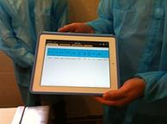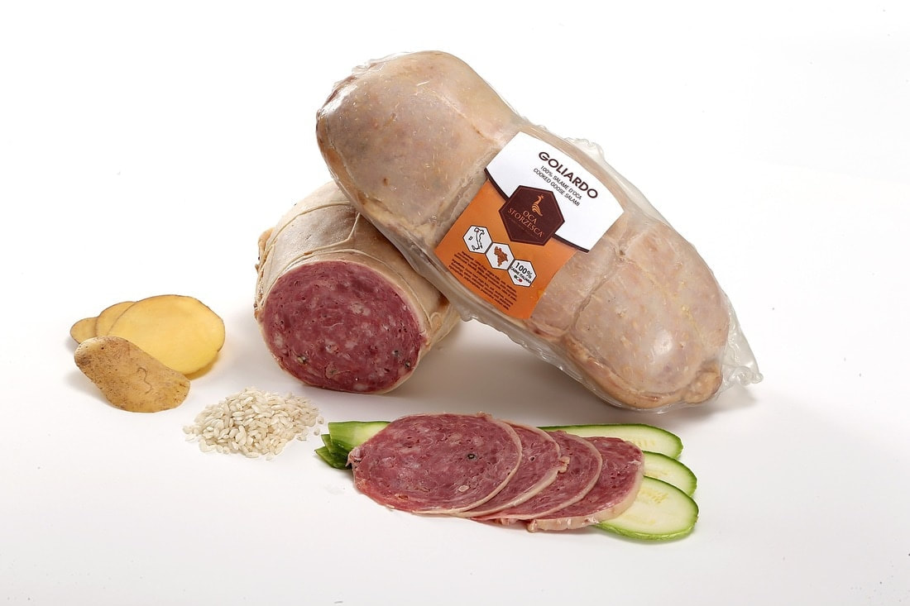
Pic.#15. PICTURES OF OCA SFORZESCA, IT
Source: archives of OCA SFORZESCA
Last but not least, based on previous data collection and interviews with the local SMEs, Pannon Novum (West-Transdanubian Region, Hungary) identified the following innovative technologies: agro-logistical topics; innovative food processing; energy consumption and gas emissions decreasing; agriculture rural development; organic farming; biodynamic vineries; rural forestry plantation; renewable resources and environment friendly economy (Pannon Novum, 2017).
The INNOGROW activity A1.2 “Identifying successful new business models for rural economy SMEs” collected types of new business models to be adopted within rural SMEs that facilitate the increase of their competitiveness.
These types of new business models were discussed among the participants of the Public consultation meetings. It has been concluded during the Public consultation meetings that the most of stakeholders, in particular, the rural entrepreneurs lack understanding of the meaning of the business model as such.
Based on the methodology of INNOGROW activity A1.2, the list of 12 new business models for rural SMEs (see Annex 6) was assessed by the participants of the Public consultation meetings. In most of the partner regions participants of the Public consultation meetings were relatively reluctant to evaluate the most appropriate business model. Reasons can be associated with a lack of knowledge and understanding of a business model as such.
Stakeholders of the partner regions from Pardubicky kraj (CZ) voted for 3 most appropriate and applicable business models – (1) R&D cooperation, (2) product diversification, (3) producer organisation/ cooperatives. Stakeholders from the regions of IT highlighted following four business models (BM) – collaborations of horizontal and vertical supply chains, R&D cooperation and public – private partnership (PPP).
Stakeholders from other partner regions, instead of voting, discussed various cases of applying different or innovative BM. Some best practise examples are included in this report. After clarifying the meaning of an innovative or different business model, some participants confirmed that they have experienced an introduction of different or innovative BMs.
The logical matrix below summarises the specific challenges or barriers faced, opportunities to be used and enablers provided by INNOGROW partner regions (Picture #16 and Picture #17).

Pic.#16. Bariers, opportunities and enablers for the adoption of innovations in rural SMEs /1
Source: prepared by the authors
Pic.#17. Bariers, opportunities and enablers for the adoption of innovations in rural SMEs /2
Source: prepared by the authors

Highlights from the interviews
Interviewees were asked to comment on the main opportunities for rural SMEs to introduce innovations and new business models. Interviewed persons were asked to refer to the results of particular INNOGROW activities (respectively A1.1, A1.2, A1.4 where their represented organisations are having the main responsibility).
Matthew Gorton (representing the University of Newcastle upon Tyne) commented that there are innovation development opportunities for both the land and non-land based industries.
There is a widespread opinion within the society, especially among smaller farmers, that agriculture is more traditional and less innovative industry. However, Matthew Gorton admitted that in case of the agriculture, there are a number of specific opportunities in relation to the precision and smart agriculture. For instance, there is the underdeveloped application of the drone and ICT based technologies.
Matthew Gorton mentioned the opportunity to create and develop the “Enterprise hubs” as one of mechanisms for stimulating the adoption of innovations within rural SMEs. He characterized these hubs with following 4 features:
- Shared office space, which is rented under more favourable conditions,
- Access to a pool of shared support services in order to reduce overhead costs of rural SMEs,
- Availability of the professional business support or advices,
- The internal (among SMEs within the hub) and external (with other stakeholders outside the hub) networking opportunities.
Venelin Dobrev (representing the Stara Zagora Regional Economic Development Agency of Bulgaria) mentioned that the most important opportunities for rural SMEs would be related to funding and introducing of new business models.
Venelin Dobrev considers that the organization of special events for presenting the importance and benefits of the introduction of innovations and new business models in the rural SMEs can enable new opportunities. Thus managers and owners of rural SMEs will be encouraged to change attitude towards innovations and adopt them into their own businesses.
According to the opinion of Venelin Dobrev, there are unused opportunities for attraction of external funding for rural SMEs. The funding from the private sources could be easier obtained, as the Investment plan for Europe is currently active. Moreover, there should be more opportunities from the public funding (regional, national grants and EU funds) to support the introduction of new business models into rural SMEs.
Additionally Venelin Dobrev mentioned that many rural SMEs lack experience and information about the availability and possibilities of using alternative funding sources. Most of the rural SMEs have not explored full potential of such funding sources as business angels, venture capital funds, crowd funding platforms and other. More information about the experience and successful cases in the attraction of an alternative funding should embolden rural SMEs.
Similarly as Matthew Gorton, Venelin Dobrev is also confident that the creation of business advisory hubs with the expert support available shall open new opportunities for rural SMEs in the adoption of innovations. This expert support to rural SMEs can cover various areas, for instance, legal framework, promoting innovative solutions among rural SMEs, providing assistance for them to applying for different grants, preparation of business plans, market research and other.
As mentioned by Venelin Dobrev, a good example of introduction of such policy support instrument can be found in the UK with the network of rural hubs that has been introduced during the interregional workshops both in Italy and Bulgaria.
Giuseppe Cutillo (representing the Chamber of Commerce of Molise) emphasised important opportunities related to the business environment of rural SMEs itself.
Giuseppe Cutillo is confident that the rural SMEs should work towards improvement of operational efficiency and profitability . Rural entrepreneurs shall seek for new opportunities to satisfy the needs of customers and increase their satisfaction. Moreover it is important to consider possibilities of launching and accessing the new markets as well as increasing the existing market share.
According to the opinion of Giuseppe Cutillo, the policy-making bodies shall improve the support with diversified funding sources for rural SMEs that promote the job creation and access to external markets.
Moreover Giuseppe Cutillo stressed that the support shall be increased to the SMEs operating in the primary sectors (e.g. agriculture, forestry, animal husbandry and aquaculture) and tertiary sectors like tourism, which employ from 10 to 49 employees. The results of other INNOGROW activities show that larger support for the adoption of innovations within rural SMEs would promote their entry into new markets and an increase of a number of jobs.
Giuseppe Cutillo added that policy-making bodies should create better platforms for the direct communication with rural SMEs in order to understand better their needs and develop more targeted policy measures towards these needs.
Summing up, the interviews show that there are several opportunities for rural SMEs to introduce innovations and new business models. More information and communication activities shall be organised about the possibilities and benefits from the adoption of innovations and new business models within rural SME. There are unused opportunities that shall improve access to the external funding for rural SMEs. Availability of non-financial support like “enterprise hubs” and business advisory support may encourage rural SMEs to exchange their traditional approach for innovations. All interviewed persons were confident that use of these opportunities should encourage rural SMEs to improve their profitability and access new markets, especially foreign markets.

Summary on development opportunities
There are five categories of opportunities identified, where each category is related to the future recommendations for the SMEs and policy makers (Picture #18), that are detailed further in the report.
Most of these opportunities are interrelated with each other, meaning that improvements in one category may require or facilitate positive changes in another category. E.g., enabling efforts for promotion of external sales may lead to insufficient production capacity of SMEs. In such situation it would be important to encourage cooperation among SMEs in similar or related sectors.

 |  |  |  | 
1. Cooperation and networking | 2. Information and training | 3. Accessibility to public support and other financing | 4. Marketing and sales promotion in international markets | 5. Availability of workforce
Pic.#18. Categories of opportunities
Source: prepared by the authors
Analysis shows that introduction of innovations and new business models brings a number of effects leading to an increase of competitiveness of rural SMEs, for instance:
- A new way of work brings additional investment opportunities,
- New approach to communicate with the customers and new approach to marketing activities, in particular using digital solutions,
- Introduction of innovations in processes and marketing,
- Possibilities to optimize the production, marketing and other costs,
- Diversification of services/ products,
- Introduction of social responsibility policy,
- Increase of efficiency and sales,
- Widening cooperation.
In long run this shall result in improvement of the profitability ratios, for instance, return on assets (ROA), which demonstrates the increase of competitiveness in financial terms. Based on the analysis of this report the Theory of Change (ToC) has been elaborated (Picture #19) for the potential intervention. The ToC presents logical relationship between the expected inputs and outcomes towards the growth of the competitiveness of rural SMEs through the adoption of innovations and new business models. The ToC identifies main challenges or barriers faced by the rural SMEs, further opportunities to implement, outcomes and further processes, which should contribute towards changes aimed. The ToC allows for evaluation of the relevance of proposed actions towards the perceived needs of rural SMEs regarding the adoption of innovations and new business models. It can be used further as the basis for development of the intervention logic of the action plans to be prepared by the project partners.

Pic.#19. The theory of change.
Source: prepared by the authors based on the analyses of this report and Consoli (2012)

SWOT analysis
SWOT analysis summarises the key issues identified during analysis regarding barriers, challenges and further opportunities for rural SMEs to adopt innovations and new business models.

Policy recommendations
Proposed recommendations should be considered as a starting point for successful development of the action plans for each partner region.
Therefore these recommendations should be used as a guide for all partner regions and should be further developed depending on the specific needs of each partner region. Timewise all recommendations are divided into three groups:
- Here and now - for immediate use by the policy-making bodies of each partner region;
- Coming soon – for the work of the relevant institutions in the nearest 2–5 years;
- On the horizon – for the medium term changes in 5–10 years.
INNOGROW project has a particular intension to provide policy recommendations regarding planning documents of the partner regions. Most of these planning documents are strategic documents for the allocation of EU funding within this period (2014-2020) (Table #7). Thus most of the recommendations targeted towards these policy documents are presented in the category “here and now”. These recommendations are specific for each region.
Table#7. Policy planning documents addressed by the recommendations
Responsible institution | Region | Country | Planning document
Lombardy Region | Lombardia | IT | Regional Operational Programme Lomardia 2014-2020 (ERDF)
Molise Region - Managing authority of Regional OP | Molise | IT | Regional Operational Programme Molise Region 2014-2020 (ERDF)
Ministry of Economics | Zemgale | LV | Latvian Operational Programme "Growth and Employment" 2014-2020
Ministry of Economy, "Economic Promotion Policies" Directorate | Stara Zagora | BG | Bulgarian Operational Programme "Innovations and Competitiveness" 2014-2020
Ministry of Industry and Trade | Pardubice region | CZ | Czech Operational Programme Enterprise and Innovations For Competitiveness 2014-2020 (ERDF)
Ministry of Economic Development and Technology, Directorate for Entrepreneurship, Competitiveness and Technology | Gorenjska | SL | Slovenian Industrial Policy 2014-2020 (SIP)
Managing Authority for Regional Development Programmes, Deputy State-Secretariat of Economic Development Programmes, Ministry of National Economy | Nyugat-Dunantul | HU | Territorial and Settlement Development OP of Hungary 2014-2020 (TOP)
Source: INNOGROW project documentation
The rest of the recommendations are envisaged for longer period and are presented in two other categories (“Coming soon” and “On the horizon”).

HERE AND NOW
These recommendations are addressed individually to each region, in particular, to institutions responsible for the implementation of the planning documents listed above.
Lombardia (IT)
Lombardia is the 2nd largest region within Italy regarding the number of institutions promoting innovations, in particular, public research institutions, innovation poles, Universities and technological districts. However, large parts of these organisations are surrounding Milano metropolis, and rural areas are underserved. Despite of the availability of research infrastructure and facilities, SMEs (potential innovation users) are reluctant towards their implementation (Arnoe and Cavallaro, 2016, Invest in Lombardy [s.a]). It is of important to promote cooperation between the rural and metropolis areas in order to facilitate development of the rural areas. The agriculture and tourism sectors are important within this region.
The main policy document addressed by the INNOGROW project in Lombardy region is the Regional Operational Programme Lomardia 2014-2020, which contains the strategy for support of the ERDF. There is a specific aim set within this document “to encourage innovation among micro, small and medium-sized enterprises”. The availability of high-quality services and external support, like business mentoring or technical advices, are provided in order to reach the aim of ROP. The 3rd priority of ROP is targeted towards the promotion of competitiveness of the SMEs. The support is planned for several directions:
- Advising services to SMEs, in particular, strategic consultations, preparation of market analyses and marketing plans of new products, assistance in the attraction of partners, mainly provided by business incubators and accelerators.
- Promotion of internationalization of SMEs and the region as such, in particular, by strengthening the export capacity and attraction of potential foreign investors,
- Support for the development of new products, in particular in tourism and culture sectors,
- Ensuring the accessibility to credits, investments (venture capital, seed and pre-seed capital) and risk management initiatives for agricultural SMEs,
- Promotion of networking and cooperation of SMEs, such as clusters and other forms of the partnership (ROP Lombardia 2014-2020).
In general, the support areas reflect the needs and further opportunities identified within this research. However, consultations with the stakeholders highlighted specific needs to be addressed.
Recommendation | Responsible policy making body | Financing source
1. To strengthen business cooperation between rural and metropolitan areas in order to promote the sales of rural SMEs in metropolitan areas and reduce development divide between both rural and metropolitan areas | Lombardy Region  Additionally involved: Chamber of Commerce | ERDF  Additionally: Horizon 2020, territorial cooperation programmes
2. To support development of organic and biotechnology ecosystem services | Lombardy Region,  Additionally involved: Regional Agency for Agriculture and Forest Services, The Italian Agroenergy Association | ERDF  Additionally: Horizon 2020, territorial cooperation programmes
3. To envisage specific support initiatives for development of R&D and innovation within rural SMEs | Lombardy Region  Additionally involved: Chamber of Commerce, Regional Agency for Agriculture and Forest Services, Higher education institutions | ERDF  Additionally: Horizon 2020, territorial cooperation programmes
4. To foresee specific support initiatives that encourage more active engagement of rural SMEs in creation and implementation of innovations through participation in innovation platforms, networks, trainings, providing “innovation vouchers”, etc. | Lombardy Region  Additionally involved: Chamber of Commerce, Regional Agency for Agriculture and Forest Services, Higher education institutions | ERDF  Additionally: Horizon 2020, territorial cooperation programmes

Molise (IT)
Molise is the second smallest region within Italy, which is primarily agricultural. Also, industrial production of mechanics, textiles, food, as well as crafts are important business sectors. Several industrial clusters operate in the region, e.g., Termoli, Campobasso-Bojano, Campobasso-Ripalimosani and Venafro-Pozzilli (European Commision, [s.a]). However, Molise region lags behind regarding the number of research institutions or networks. This number is the 2nd lowest among the regions in Italy (Arnoe and Cavallaro, 2016).
The main policy document addressed by the INNOGROW project in Molise region is the Regional Operational Programme Molise 2014-2020, which contains the strategy for support of the ERDF. This ROP is aiming at fostering the growth of the competitiveness of SMEs and strengthening the innovation capacity. The 3rd priority of ROP is targeted towards promotion of competitiveness of SMEs with a particular contribution towards the Smart Specialisation Strategy (RIS3). The support is planned for several directions:
- Facilitation of rural SMEs to expand in regional, national and international markets,
- Encouraging rural SMEs in innovations,
- Ensuring the accessibility to credits, investments (venture capital, seed and pre-seed capital) and risk management initiatives for agricultural SMEs,
- Rearranging of production by integrating innovative approaches and business models (ROP Molise 2014-2020).
Besides the support envisaged, consultations with the stakeholders highlighted additional areas of to be addressed.
Recommendation | Responsible policy making body | Financing source
1. To ensure more targeted consultations and information specifically to rural SMEs on the innovation support available | Molise Region  Additionally involved: Chamber of Commerce | ERDF  Additionally: territorial cooperation programmes
2. To ensure support for the development and implementation of digital marketing activities within rural SMEs (by using IT and social media) | Molise Region  Additionally involved: Chamber of Commerce | ERDF  Additionally: territorial cooperation programmes
3. In order to facilitate the expansion of rural SMEs in national and international markets, to ensure the development of regional unique branding, for instance, renewing the regional brand “Piacere Molise” | Molise Region  Additionally involved: Chamber of Commerce | ERDF  Additionally: territorial cooperation programmes, ESPON
4. Promotion of the vertical and horizontal (among rural SMEs and with other stakeholders) partnership platforms for SMEs that can facilitate the creation and implementation of new technologies, products and business models | Molise Region  Additionally involved: Chamber of Commerce, industrial clusters represented in the region (see above) | ERDF  Additionally: Horizon 2020, territorial cooperation programmes

Nyugat-Dunantul (HU)
Nyugat-Dunantul is the second most developed region after Central Hungary. The industrial sector is comparatively strong and steady. Automative and machinery industries are the most important sectors. A number of export-oriented subsidiaries of the multi national companies are located there (e.g. Audi, Opel, etc.). The service sector is developing, where tourism is the key sector. However, the research and innovation capacity is relatively weak. In recent years more efforts are dedicated to strengthen this sector. The region is rich with the natural resources of thermal and mineral waters and two large UNESCO World Heritage sites are situated there (European Commission, [s.a.], Scinnopoli [s.a]).
The main policy document addressed by the INNOGROW project is the Territorial and Settlement Development OP of Hungary 2014-2020. First priority of the TOP is focused on the promotion of business capability and improvement of the business environment. The support is envisaged for the municipalities to develop local business related infrastructure and ensure services that facilitate the growth of the competitiveness of SMEs. It includes:
- Support for the business incubators,
- Support for the innovation and logistics centres,
- Support for the rural SMEs, through such services as storage, cooling, sorting and packaging of the products (TOP Hungary 2014-2020).
TOP only partly covers the future development needs of the rural SMEs. Moreover, the Rural Development programme is seen as the important tool for the development of rural areas that should be taken into account. It is suggested to coordinate the implementation of the recommendations with the RDP.
Recommendation | Responsible policy making body | Financing source
1. Provision of the support for the development of innovations specifically within rural SMEs | The Ministry of Economy  Additionally involved: Pannon Novum West Pannon Regional Innovation Agency, The National Research, Development and Innovation Office, Chamber of Commerce and Industry | ERDF  Additionally: territorial cooperation programmes
2. Support for the development of innovations, new products and business models of the agricultural and agro-tourism rural SMEs, in particular, regarding the biodynamic and organic products (under RDP) | The Ministry of Agriculture and Rural Development | EAFRD  Additionally: territorial cooperation programmes
3. To encourage a more active participation of rural SMEs in innovation platforms and networks | The Ministry of Economy  Additionally involved: Pannon Novum West Pannon Regional Innovation Agency, The National Research, Development and Innovation Office, Chamber of Commerce and Industry, Higher Education Institutions | ERDF  Additionally: Horizon 2020, territorial cooperation programmes
4. To ensure support for rural SMEs for the registration of the intellectual property rights | The Ministry of Economy  Additionally involved: Pannon Novum West Pannon Regional Innovation Agency, The National Research, Development and Innovation Office, Chamber of Commerce and Industry | ERDF  Additionally: territorial cooperation programmes

Zemgale (LV)
Zemgale region is located in the central part of Latvia, relatively close to the capital. The agriculture and related fields are the most important business sectors in Zemgale. Recently the development of crafts and local (rural) producers has been facilitated. The University of Agriculture of Latvia, located in Zemgale region, provides a strong capacity for the development of innovations and research within this region. In addition, a number of scientific and research institutions related to the field of agriculture and forestry are located within this region (ZPR IAS 2015-2030).
The main policy document relevant to the INNOGROW project is the Operational Programme “Growth and employment”. This is a national level strategic document for the implementation of EU Structural Funds in 2014-2020. The OP does not specifically address the rural SMEs. However, the 3rd priority of the OP aims to increase the competitiveness and the innovation capacity of SMEs, in general throughout Latvia. It has a specific emphasis to contribute to the Smart Specialisation strategy (RIS3). The support is envisaged for diverse support measures, including:
- Support for the promotion of the development of innovations within SMEs with higher growth potential, creation of new high value added products,
- Access to financing, such as investments (venture capital, seed and pre-seed capital), credits, guarantees,
- Development of business related infrastructure and consultancies, for instance, business incubators, clusters,
- Promotion of the internationalisation of SMEs.
This OP just partly covers the future development needs of rural SMEs. In Latvia, similarly as in Hungary, the Rural Development programme is seen as an important tool for the development of rural areas that should be taken into account. It is suggested to coordinate the implementation of the recommendations with the RDP.
Recommendation | Responsible policy making body | Financing source
1. Promotion of vertical and horizontal (among rural SMEs and with other stakeholders) partnership platforms for SMEs that can facilitate creation and implementation of new technologies, products and business models | Ministry of Economy  Additionally: Administration of Zemgale region, Latvian Investment and Development Agency, Higher education institutions | ERDF  Additionally: Horizon 2020, territorial cooperation programmes
2. To encourage access of the rural non-agricultural SMEs to wider national and international markets | Ministry of Economy and Ministry of Agriculture  Additionally: Latvian Investment and Development Agency, Rural Support Service, Chamber of Commerce, Administration of Zemgale region | ERDF, EAFRD  Additionally: territorial cooperation programmes
3. To ensure information and training of rural SMEs on introduction of new business models and innovations | Ministry of Economy and Ministry of Agriculture  Additionally: Latvian Investment and Development Agency, Rural Support Service, Chamber of Commerce, Administration of Zemgale region | ERDF, EAFRD  Additionally: territorial cooperation programmes
4. To ensure specific support initiative/ measure for the development of innovations and new business models specifically in rural non-agricultural SMEs | Ministry of Economy and Ministry of Agriculture  Additionally: Latvian Investment and Development Agency, Rural Support Service, Chamber of Commerce, Administration of Zemgale region | ERDF, EAFRD  Additionally: territorial cooperation programmes
5. To simplify the application and implementation of the projects supporting development of new products and other innovative technologies | Ministry of Economy and Ministry of Finance,  Additionally: Central Finance and Contracting Agency | ERDF

Pardubice region (CZ)
Pardubice region is characterised as an agricultural – industrial region. This region has long traditions of primary agricultural production. The service sector is of minor importance, but it is gradually developing. The research and innovation ecosystem of the region is comparatively weak. However, recently efforts have been put to strengthen the innovation environment. For instance, the Smart Accelerator project is focused on the improvement of the innovation capacity and environment of the region thus directly contributing to the Smart specialisation strategy (RIS3). The economic development of region is partly hindered by the comparatively weak transport infrastructure and connectivity (Pardubice [s.a], Matatkova and Stejskal, 2013).
The main policy document relevant to the INNOGROW project is the Czech Operational Programme “Enterprise and Innovations for Competitiveness 2014-2020 (ERDF)”. There is a specific priority envisaged aiming at the development of the entrepreneurship and competitiveness. This programme shall enhance the innovation capacity of the SMEs and contribute to the Smart Specialisation Strategy (RIS3). There are diverse support measures enlisted, including:
- Support for starting a business,
- Consultations to business related infrastructure and facilities, such as, business incubators, science and technology parks and innovation centers,
- Promotion of the internationalisation of SMEs.
However, the OP only partly covers the future development needs of the rural SMEs.
Recommendation | Responsible policy making body | Financing source
1. To ensure support for development of public transport infrastructure that improve the accessibility of the region | Ministry of Industry and Trade | ERDF
2. Promotion of vertical and horizontal (among rural SMEs and with other stakeholders) partnership platforms for rural SMEs that can facilitate creation and implementation of new technologies, products and business models | Ministry of Industry and Trade  Additionally: Pardubice region, Higher education institutions, Regional Chamber of Commerce, Energy – Industrial Innovation Cluster | ERDF  Additionally: Horizon 2020, territorial cooperation programmes
3. To ensure more targeted consultations and the information specifically to rural SMEs on the innovation support available | Ministry of Industry and Trade  Additionally: Pardubice region, | ERDF  Additionally: territorial cooperation programmes
4. To simplify the application and implementation of the projects supporting the development of new products and other innovative technologies | Ministry of Industry and Trade | ERDF

Gorenjska (SL)
Gorenska region is one of the developed regions, that is located in the north-west part of Slovenia. Manufacturing and tourism with the ski resorts are important sectors in this region. the The majority of the agricultural SMEs are related to the cattle breeding. This region borders with Austria and Italy, and possesses a comparatively well–developed transport infrastructure that facilitates the economic development of this region (Invest Slovenia, [s.a.]).
The main policy document relevant to the INNOGROW project is the Slovenian Industrial Policy 2014-2020 (SIP). This is a national level policy document addressing the whole country. There are several objectives set to address the challenges related to the competitiveness and the innovation capacity of SMEs. It has a specific emphasis to contribute to the Smart Specialisation strategy (RIS3). The support covers several directions, such as:
- Support related to the promotion of non-technological innovations and new business models,
- R&D activities and support to industrial sectors with higher technological potential,
- Promotion of the internationalisation of SMEs (SIP).
In general, the support areas reflect the needs and further opportunities identified within this report. However, consultations with the stakeholders highlighted specific needs to be addressed regarding the rural SMEs.
Recommendation | Responsible policy making body | Financing source
1. To ensure information and training for rural SMEs on introduction of new business models and innovations | Ministry of Economic Development and Technology, Directorate for Entrepreneurship, Competitiveness and Technology  Additionally: the Slovenian Rural Network, business incubators and clusters, Business support centre ltd. Kranj | ERDF  Additionally: territorial cooperation programmes
2. Promotion of vertical and horizontal (among rural SMEs and with other stakeholders) partnership platforms for SMEs that can facilitate creation and implementation of new technologies, products and business models, for instance clusters or other initiatives | Ministry of Economic Development and Technology, Directorate for Entrepreneurship, Competitiveness and Technology,  Additionally: the Slovenian Rural Network, business incubators and clusters, Slovenian Centre for Competitiveness and Innovation, Business support centre ltd. Kranj | ERDF  Additionally: Horizon 2020, territorial cooperation programmes
3. To ensure specific support initiative/ measure for the development of innovations and new business models specifically in rural SMEs | Ministry of Economic Development and Technology, Directorate for Entrepreneurship, Competitiveness and Technology  Additionally: the Slovenian Rural Network, business incubators and clusters, Business support centre ltd. Kranj | ERDF  Additionally: Horizon 2020, territorial cooperation programmes
4. To ensure specific support initiatives for rural SMEs for the sales promotion in international markets in order to facilitate their expansion in international markets | Ministry of Economic Development and Technology, Directorate for Entrepreneurship, Competitiveness and Technology  Additionally: the Slovenian Rural Network, business incubators and clusters, Business support centre ltd. Kranj, Slovene Enterprise Fund, Slovenian Regional Development Fund | ERDF  Additionally: territorial cooperation programmes

Stara Zagora (BG)
Stara Zagora region has a favourable geographical location providing an easy access to important trading transport routes and is operating as an intermodal transport hub having connection to other cities of Bulgaria. (Invest Bulgaria, [s.a.]). This region has recently improved the ICT related infrastructure, that facilitates the use of digital technologies. Production of lignite coal and electrical energy are important business sectors of this region. Other important business sectors are construction, food production and cosmetics. Textile or clothing manufacturing has historical traditions, which are still kept by the larger entrepreneurs. Agriculture forms comparatively small share in the economy of this region.
The main policy document relevant to the INNOGROW project is the Bulgarian Operational Programme "Innovations and Competitiveness" 2014-2020. This OP is a national level planning document of the EU Structural Funds. This document is aiming to increase the competitiveness of SMEs. It has a specific emphasis to contribute to the Smart Specialisation strategy (RIS3). The support is envisaged for diverse support measures, including:
- Accessibility to financing of SMEs through financial instruments combined with grants,
- Strengthening the productivity and export potential of SMEs,
- Support for specialized services to SMEs to develop and strengthen the management capacity, use of ICT.
In general, the support areas reflect the needs and further opportunities identified within this report. However, consultations with the stakeholders highlighted specific needs to be addressed regarding the rural SMEs.
Recommendation | Responsible policy making body | Financing source
1. Promotion of vertical and horizontal (among rural SMEs and with other stakeholders) partnership platforms for SMEs that can facilitate creation and implementation of new technologies, products and business models, for instance clusters or other initiatives | Ministry of Economy, "Economic Promotion Policies" Directorate  Additionally: higher education and research institutions, the Chamber of Commerce, Stara Zagora regional Administration | ERDF  Additionally: Horizon 2020, territorial cooperation programmes
2. Promotion of the technology transfer from the scientific institutions to rural SMEs | Ministry of Economy, "Economic Promotion Policies" Directorate  Additionally: higher education and research institutions, Stara Zagora regional Administration | ERDF  Additionally: Horizon 2020, territorial cooperation proogrammes
3. To ensure consultations and support to the rural SMEs for registration of the intellectual property rights and trade marks | Ministry of Economy, "Economic Promotion Policies" Directorate  Additionally: Stara Zagora regional Administration | ERDF
4. To ensure more targeted consultations and information specifically to rural SMEs on development of innovations and funding available | Ministry of Economy, "Economic Promotion Policies" Directorate  Additionally: higher education and research institutions, the Chamber of Commerce, Stara Zagora regional Administration | ERDF
5. To encourage access of the rural SMEs to the wider national and international markets | Ministry of Economy, "Economic Promotion Policies" Directorate  Additionally: the Chamber of Commerce, Stara Zagora regional Administration | ERDF  Additionally: territorial cooperation programmes

COMING SOON and ON THE HORIZON
Analysis of this research shows that there are numerous public support programmes for the promotion of innovations. However, these programmes are not always accessible for rural SMEs. There is a need for several improvements common to all participating regions that can be implemented beyond this planning period of the EU funds. These recommendations are targeted towards all regions participating in the INNOGROW project and can be introduced in the policy planning documents beyond 2020. These recommendations are grouped according to the categories of the opportunities provided in the section 4.4. of this report (See picture 18 and picture 19).
Cooperation and networking
Recommendation | Responsible body | Financing source | Implementation time
1. To promote creation and assist with maintaining of the thematic clusters or functional cooperation networks among SMEs operating in similar or related sectors, which opens wide opportunities:  - To share resources and thus reduce costs;  - To combine the capacity in the production of larger customer orders;  - To create “sufficient critical mass” through cooperation in order to be able to compete with large companies;  - To share knowledge and find solutions for common problems. | Local and regional authorities, national public authorities responsible for the innovation and entrepreneurship promotion, as well as rural development, NGOs representing entrepreneurs and rural communities, international cooperation platforms being active and recognized within partner regions | EU structural funds, specific EU programmes and initiatives (e.g. Interreg, Horizon 2020), other financial support instruments (e.g. EEA grants) | COMING SOON
2. To create co-working space or hub for rural SMEs, providing premises, office equipment and business consultations.  Some regions/countries have also an experience in developing municipal libraries as business centres or hubs. | Local and regional authorities, national public authorities responsible for the innovation and entrepreneurship promotion, as well as rural development NGOs representing entrepreneurs and rural communities | EU structural funds, specific EU programmes and initiatives (e.g. Interreg, Horizon 2020), other financial support instruments (e.g. EEA grants) | COMING SOON
3. Interregional cooperation in creating and promoting common products in priority sectors. | Local and regional authorities, NGOs representing entrepreneurs and rural communities | EU structural funds, specific EU programmes and initiatives (e.g. Interreg, Horizon 2020), other financial support instruments (e.g. EEA grants) | COMING SOON

Information and training
Recommendation | Responsible body | Financing source | Implementation time
1. Ensure regular consultations and other “innovation motivation” activities on introduction of innovative technologies and new business models for rural SMEs in order to keep them motivated and engaged in the innovations. | Local and regional authorities, NGOs representing entrepreneurs and rural communities, international cooperation platforms being active and recognized within partner regions | EU structural funds, specific EU programmes and initiatives (e.g. Interreg) | COMING SOON
2. Organise business success and failure stories, such as “Business breakfast or lunch”, where rural entrepreneurs meet and exchange experience. | Local and regional authorities, NGOs representing entrepreneurs and rural communities | EU structural funds, specific EU programmes and initiatives (e.g. Interreg) other financial support instruments (e.g. EEA grants), own resources of municipal/ regional authorities | COMING SOON
3. Ensure training programmes on new business models and innovations to farmers that are adjusted to the time periods when there is less work in the fields or provide online training programmes. | NGOs representing entrepreneurs and rural communities, higher education, VET, life-long learning institutions | EU structural funds, specific EU programmes and initiatives (e.g. Interreg) other financial support instruments (e.g. EEA grants) | COMING SOON
4. Create and expand training programmes focused on the use of ICT and social media for distribution and marketing of the products of rural SMEs. | NGOs representing entrepreneurs and rural communities, higher education, VET, life-long learning institutions | EU structural funds, specific EU programmes and initiatives (e.g. Interreg) other financial support instruments (e.g. EEA grants) | COMING SOON
5. Implement activities and projects that promote the innovation culture among pupils and youth (the future entrepreneurs). | Local and regional authorities, NGOs representing entrepreneurs and rural communities, schools, higher education, VET, life-long learning institutions | EU structural funds, specific EU programmes and initiatives (e.g. Interreg, Erasmus+) other financial support instruments (e.g. EEA grants) | COMING SOON

Marketing and sales promotion in international markets
Recommendation | Responsible body | Financing source | Implementation time
1. To ensure sales agents or sales promotion assistants within external countries. | Regional authorities, national public authorities responsible for the innovation and entrepreneurship promotion, as well as rural development | EU structural funds, specific EU programmes and initiatives (e.g. Interreg) other financial support instruments (e.g. EEA grants) | COMING SOON
2. To advise and assist small rural SMEs to start cooperation with foreign business partners and conclude contractual relations with them. | Local and regional authorities, NGOs representing entrepreneurs and rural communities, international cooperation platforms being active and recognized within partner regions | EU structural funds, specific EU programmes and initiatives (e.g. Interreg) other financial support instruments (e.g. EEA grants) | COMING SOON
3. To create informative webpage informing about the business and investment opportunities within the particular regions.  (Some of the partner regions already have such type of web pages either hosted by national or regional authorities, for instance, Invest in Lombary) | Regional authorities, NGOs representing entrepreneurs and rural communities | EU structural funds, specific EU programmes and initiatives (e.g. Interreg) other financial support instruments (e.g. EEA grants) | COMING SOON
4. Develop an identity or a branding of a region and perform marketing and other promotional activities in order to promote the products of rural SMEs and business cooperation possibilities | Regional authorities, NGOs representing entrepreneurs and rural communities | EU structural funds, specific EU programmes and initiatives (e.g. Interreg) other financial support instruments (e.g. EEA grants) | ON THE HORIZON

Availability of the workforce
Recommendation | Responsible body | Financing source | Implementation time
1. To encourage cooperation among small rural SMEs to minimise costs for logistic services (in delivery of products or supply of raw materials) | Regional authorities, NGOs representing entrepreneurs and rural communities | EU structural funds, specific EU programmes and initiatives (e.g. Interreg) other financial support instruments (e.g. EEA grants) | COMING SOON
2. To encourage introduction of the diversity management, smart & flexible work initiatives within rural SMEs | Local and regional authorities, national public authorities responsible for the innovation and entrepreneurship promotion, as well as rural development, NGOs representing entrepreneurs and rural communities, higher education institutions | EU structural funds, specific EU programmes and initiatives (e.g. Interreg) other financial support instruments (e.g. EEA grants) | COMING SOON
3. To facilitate use of distant work (e-work), thus allowing knowledge economy professionals to live and work in rural areas, while maintaining a job in companies operating in the urban areas | Local and regional authorities, national public authorities responsible for the innovation and entrepreneurship promotion, as well as rural development, NGOs representing entrepreneurs and rural communities | EU structural funds, specific EU programmes and initiatives (e.g. Interreg) other financial support instruments (e.g. EEA grants) | COMING SOON
4. To encourage the cooperation between rural SMEs and VET institutions in education and internship | Regional authorities, national public authorities responsible for the innovation and entrepreneurship promotion, as well as rural development, NGOs representing entrepreneurs and rural communities, higher education, VET institutions | EU structural funds, specific EU programmes and initiatives (e.g. Interreg) other financial support instruments (e.g. EEA grants) | COMING SOON
5. To create a specific support initiative for the attraction of highly professional employees and managers, such as “Rent a boss” for innovation development | Regional authorities, national public authorities responsible for the innovation and entrepreneurship promotion, as well as rural development | EU structural funds, specific EU programmes and initiatives (e.g. Interreg) other financial support instruments (e.g. EEA grants) | ON THE HORIZON
6. To undertake social campaigns to change the perception of the countryside and promote it as a high-quality place to live | Regional authorities, national public authorities responsible for the rural development, NGOs representing rural communities | EU structural funds, specific EU programmes and initiatives (e.g. Interreg) other financial support instruments (e.g. EEA grants)  National budget | ON THE HORIZON
7. To develop training programmes in VET institutions that are based in the business environment (part of the learning process is organised within particular companies) | Regional authorities, national public authorities responsible for the innovation and entrepreneurship promotion, as well as rural development, NGOs representing entrepreneurs and rural communities, higher education, VET institutions | EU structural funds, specific EU programmes and initiatives (e.g. Interreg) other financial support instruments (e.g. EEA grants)  National budget | ON THE HORIZON
8. Reshape/ improve the attitude of the society towards the VET | Regional authorities, national public authorities responsible for the innovation and entrepreneurship promotion, as well as rural development, NGOs representing entrepreneurs and rural communities, higher education, VET institutions | EU structural funds, specific EU programmes and initiatives (e.g. Interreg) other financial support instruments (e.g. EEA grants) | ON THE HORIZON

Accessibility to public support and other financing
Recommendation | Responsible body | Financing source | Implementation time
1. To ensure permanent innovation support measures for rural SMEs available on a competitive basis all year round | Regional authorities, national public authorities responsible for the innovation and entrepreneurship promotion | EU structural funds, specific EU programmes and initiatives (e.g. Interreg) other financial support instruments (e.g. EEA grants) | COMING SOON
2. To develop support measures for rural youth willing to start a business | Local and Regional authorities, national public authorities responsible for the innovation and entrepreneurship promotion, as well as rural development, NGOs representing entrepreneurs and rural communities, schools | EU structural funds, specific EU programmes and initiatives (e.g. Interreg) other financial support instruments (e.g. EEA grants) | COMING SOON
3. Introduce “Innovation Vouchers” that allows easily to receive small scale support for the creation and development of innovations | Regional authorities, national public authorities responsible for the innovation and entrepreneurship promotion, as well as rural development NGOs representing entrepreneurs and rural communities | EU structural funds, specific EU programmes and initiatives (e.g. Interreg) other financial support instruments (e.g. EEA grants) | COMING SOON
4. Introduce “Design Vouchers” that allows easily to receive small scale support for the creation of competitive design and branding of new products | Regional authorities, national public authorities responsible for the innovation and entrepreneurship promotion, as well as rural development NGOs representing entrepreneurs and rural communities | EU structural funds, specific EU programmes and initiatives (e.g. Interreg) other financial support instruments (e.g. EEA grants) t | COMING SOON
5. Introduce “ICT Innovation Vouchers” that allows easily to receive small scale support for introducing ICT in the business model (e.g. creating a website, enhancing supply chain management and customer relationship management with ICT tools) | Regional authorities, national public authorities responsible for the innovation and entrepreneurship promotion, as well as rural development NGOs representing entrepreneurs and rural communities | EU structural funds, specific EU programmes and initiatives (e.g. Interreg) other financial support instruments (e.g. EEA grants) t | COMING SOON
6. To create specific support initiative for youth and children to encourage development of new products and business projects | Local and Regional authorities, national public authorities responsible for the innovation and entrepreneurship promotion, as well as rural development, NGOs representing entrepreneurs and rural communities, schools | EU structural funds, specific EU programmes and initiatives (e.g. Interreg) other financial support instruments (e.g. EEA grants)  National budget | ON THE HORIZON
7. To develop special support measures for rural SMEs performing social and environmental functions | Regional authorities, national public authorities responsible for the innovation and entrepreneurship promotion, as well as rural development NGOs representing entrepreneurs and rural communities | EU structural funds, specific EU programmes and initiatives (e.g. Interreg) other financial support instruments (e.g. EEA grants) | ON THE HORIZON
8. To encourage local and regional governing bodies to envisage and create local/regional support programmes for local/rural SMEs and people willing to start their business in rural areas | Local and Regional authorities, national public authorities responsible for the innovation and entrepreneurship promotion, as well as rural development NGOs representing entrepreneurs and rural communities, schools | EU structural funds, specific EU programmes and initiatives (e.g. Interreg) other financial support instruments (e.g. EEA grants)  National budget | ON THE HORIZON

Bibliography
- Adamowicz, M. (2017). Bio-economy as an element of development strategies in the European Union. Economic Science for Rural Development Conference Proceedings No. 44, pp.237-247.
- Arnone, M., and Cavallaro, C. (2016). The challenge of a place-and network-based approach to development in Italian regions. Procedia-Social and Behavioral Sciences No. 223, pp. 31-36.
- Autine Tools Company SIA [s.a], available at: www.autinetools.com/en
- Bonciu F. (2016). The Circular Economy: From a Linear to a Circular Economy. Romanian Journal of European Affairs, Vol. 14, Issue 4, pp. 78-91.
- Bonciu, F., Balgar, A.C. (2016). Sharing Economy as a Contributor to Sutainable Growth. An EU Perspective. Romanian Journal of European Affairs, Vol. 16 Issue 2, pp. 36-45.
- Bulgarian Operational Programme "Innovations and Competitiveness" 2014-2020.
- Ceapraz I.L., Delhoume C. (2017). How social capital can improve the territorial innovation? The Case of the French agriculture. Some conceptual issues. Romanian Journal of Regional Science. Vol. 11, Issue 2, pp. 26-35.
- Cei, L., Stefani, G., Defrancesco, E., & Lombardi, G. V. (2017). Geographical Indications: a first assessment of the impact on rural development in Italian NUTS3 regions (No. wp2017_14. rdf). Universita'degli Studi di Firenze, Dipartimento di Scienze per l'Economia e l'Impresa.
- Chamber of Commerce of Molise (2017). “Public Consultation Meeting Summary”, 5 p.
- Cimdiņa, A. (2014). Unnoticed Entrepreneurship and Innovation in Latvia’s Rural Economy. Journal of Baltic Studies, 45(1), pp. 79-104.
- Commission Recommendation 2003/361/EC of 6 May 2003 concerning the definition of micro, small and medium-sized enterprises (Text with EEA relevance), Official Journal L 124, p. 36-41, of 20 May 2003.
- Connect to Grow (2016). Supporting SME growth through innovation and partnership: a review of the landscape. Available at: http://www.inclusivebusinesshub.org/wp-content/uploads/2016/02/Connect-Baseline-FINAL_public-July-2016.pdf
- Consoli D. (2012). Literature analysis on determinant factors and the impact of ICT in SMEs. Procedia-social and behavioral sciences, 62, pp.93-97.
- Costea-Dunarintu A. (2016). The Circular Economy in the European Union. Knowledge Horizons / Orizonturi ale Cunoasterii, Vol. 8, Issue 1, pp. 148-150.
- Cowie P., Thompson N. and Rowe F. (2013). Honey Pots and Hives: Maximising the potential of rural enterprise hubs. Centre for Rural Economy, Newcastle University.
- Darnell, D., Gadiesh, O. “Gender equality in UK”, Bain& Company, 2013.
- David Smallbone, Robert Baldock, David North. Policy support for small firms in rural areas: the English experience, Environment and Planning C: Government and Policy 2003, Vol 21, pages 825-841.
- Deloitte (Deloitte Development LLC.) (2018). The Fourth Industrial Revolution is here—are you ready? Deloitte Insights. Available at: https://www2.deloitte.com/content/dam/insights/us/articles/4364_Industry4-0_Are-you-ready/4364_Industry4-0_Are-you-ready_Report.pdf
- EPC (Energy Performance Contracting Plus), [s.a], http://epcplus.org/arguments-for-sme-partnerships/
- ESPON & UHI Millennium Institute (2017), “EDORA – European Development Opportunities for Rural Areas”. Applied Research 2013/1/2. Final Report Parts A, B and C. 84 p., available at: https://www.espon.eu/programme/projects/espon-2013/applied-research/edora-european-development-opportunities-rural-areas
- European Commission, 2017a. Annual Report on European SMEs. 2016/2017. Focus on self-employment. SME Performance Review2016/2017.
- European Commission, 2017b. Communication from the Commission to the European Parliament, the Council, the European Economic and Social Committee and the Committee of Regions - Strengthening Innovation in Europe's Regions: Strategies for resilient, inclusive and sustainable growth. Brussels, COM (2017), 376.
- European Commission, 2017c. Review of the 2012 European Bioeconomy Strategy.
- European Commission, [s.a.]. Regional Innovation Monitor, available at: https://ec.europa.eu/growth/tools-databases/regional-innovation-monitor/base-profile
- Eurostat (2017). Regional statistics by NUTS classification, available at: http://ec.europa.eu/eurostat/web/regions/data/database
- Eurostat, JRC and European Commission Directorate-General for Regional Policy (2017). Urban-rural typology, available at: http://ec.europa.eu/eurostat/statistics-explained/index.php/Urban-rural_typology
- Felicetti, M. (2016). Cultural innovation and local development: Matera as a cultural district. Procedia-Social and Behavioral Sciences, 223, pp. 614-618.
- Fieldsend A.F. (2013). Rural Renaissance: an integral component of regional economic resilience. Studies in Agricultural Economics. Vol. 115, pages 85-91.
- Galloway, Laura. (2007). Can broadband access rescue the rural economy?. Journal of Small Business and Enterprise Development. Vol 14. 641-653.
- Garelli S. (2006). Competitiveness of Nations: the Fundamentals, IMD, Lausanne.
- Hanappi-Egger, E. (2012). “Shall I stay or shall I go”? On the role of diversity management for women's retention in SET professions. Equality, Diversity and Inclusion: AN international journal, 31(2), pp.144-157.
- IMD (IMD World Competitiveness Center) (2017). IMD World Competitiveness Yearbook 2017. Executive summary.
- INNOGROW project documentation, unpublished information.
- Invest Bulgaria, [s.a.], available at: http://www.investbulgaria.com/StaraZagora.php
- Invest in Lombary Region (s.a.), available at: www.investinlombardy.com/lombardy/lombardy-region.
- Invest Slovenia [s.a.], available at: https://www.investslovenia.org/locations/gorenjska-region/
- Ionela G.P., Constantin B.M, Lia-Dorica Dogaru L.D. (2015). Advantages and Limits for Tourism Development in Rural Area (Case Study Ampoi and Mure Valleys). Procedia Economics and Finance Vol. 32, pp.1050 – 1059.
- Jankova L., Grizane T., Jurgelane I., Auzina A. (2017). Social Capital as the development support tool in Zemgale region. Economic Science for Rural Development Conference Proceedings. 2017, Issue 46, pp. 68-76.
- Kingdom of Rabits [s.a.], available at: http://www.trusukaraliste.lv/piedavajumsviesiem.html
- Kruszilicika M., Verginia Chiritescu V., Gavrilescu C., Viorica Gavrila V., Andrei D.R. (2014). The structure of the rural economy in Romania. Case study on macro-region 2. Bulletin UASVM Agriculture 71(1)/2014.
- Kubickova L., Moravkova M., Tuzova M., Necas I. (2017). The Role of Small and Medium Sized Enterprises in the Development of Rural Areas. Acta Universitatis Agriculturae et Silviculturae Mendelianae Brunensis, Vol 65(6): 1987 – 1996.
- Lanfranchi M., Giannetto C. (2014). Sustainable development in rural areas: The new model of social farming. Calitatea, 15(S1), 219.
- Latvijas Avīze (2016). Nākotnes saimniecība – Jānis Vinters sildīs siltumnīcu ar biešu biogāzi. Available at: http://www.la.lv/ar-biesu-biogazi-sildis-siltumnicu/
- Lombardy Foundation for the Environment, FLA (2017). “INNOGROW project – public consultation meeting”.
- Lopez M. & Pastor R. (2015). Development in rural areas through capacity building and education for business. Procedia-Social and Behavioral Sciences, 197, pp. 1882-1888.
- Mano Guru [s.a.]. available at: http://www.manoguru.lt/veiklos-tikslai-ir-uzdaviniai/
- Matatkova K. and Stejskal J. (2013). Descriptive analyses of the regional innovation system - novel method for public administration authorities. Transylvanian Review of Administrative Sciences, No. 39 E/2013, pp. 91-107.
- McKinsey&Company, (2007), “Gender diversity, a corporate performance driver”, Women Matter, McKinsey&Company.
- Miceikiene A. (2017). Review on International & National Conferences and Seminars. Rural development 2017: Bioeconomy Challenges. Transformations in Business and Economics, Vol. 16, No 3 (42), pp. 286 – 289.
- Newcastle University (2017). “Impact analysis report on main new technologies’ for rural economy SMEs”, INNOGROW project, the activity A1.1.
- OCA SFORZESCA S.r.l. [s.a.], available at: http://www.ocasforzesca.eu/traceability.html
- Osterwalder, A., & Pigneur, Y. (2010). Business model generation: a handbook for visionaries, game changers, and challengers. John Wiley & Sons.
- Pardubice [s.a.], available at: https://www.pardubickykraj.cz
- Pannon Novum (2017). “The summary report of the Public Consultations meeting”, 8 p.
- Privitera, D. (2016). Describing the Collaborative Economy: Forms of Food Sharing Initiatives. Economic Science for Rural Development Conference Proceedings. Issue 43, pp. 92-98.
- PWC (PricewaterhouseCoopers LLP), a Delaware limited liability partnership (2015). The Sharing Economy. Consumer Intelligence Series. Available at: https://www.pwc.com/us/en/industry/entertainment-media/publications/consumer-intelligence-series/assets/pwc-cis-sharing-economy.pdf
- Regional Development Agency of Gorenjska, BSC Business Support Centre L.t.d., Kranj (2017). “The summary report of the Public consultations meeting”.
- Regional Development Agency of the Pardubice Region (2017). “The Summary Report of the Public Consultation Meeting”.
- Regional Operational Programme Lomardia 2014-2020 (ROP Lombardia 2014-2020).
- Regional Operational Programme Molise 2014-2020 (ROP Molise 2014-2020).
- Richter, R. (2017). Rural social enterprises as embedded intermediaries: The innovative power of connecting rural communities with supra-regional networks. Journal of Rural Studies.
- S3 Platform, European Commission [s.a.], What is Smart Specialisation?, available at: http://s3platform.jrc.ec.europa.eu/what-is-smart-specialisation-
- Scinnopoli [s.a.], available at: http://www.scinnopoli.eu/Partner_Region_Nyugat.html
- Schön, O. (2012). Business model modularity–a way to gain strategic flexibility?. Controlling & Management, 56(2), pp. 73-78.
- Singh S., Bhowmick B. (2015). An Exploratory Study for Conceptualization of Rural Innovation in Indian Context. Procedia-Social and Behavioral Sciences, 207, pp. 807-815.
- Smallbone D., North D. (1999) Innovation and New Technology in Rural Small and Medium-Sized Enterprises: Some Policy Issues. Environment and Planning C: Politics and Space. Vol 17, Issue 5, pp. 549 – 566.
- Stara Zagora Regional Economic Development Agency (2017). “Methodology to collect and exchange cases of new business models for rural economy SMEs & corresponding dataset”, INNOGROW project, the activity A1.2.
- Stara Zagora Regional Economic Development Agency (2017). “Public consultation meeting in Stara Zagora (Bulgaria) for the INNOGROW project”.
- Sumedrea S., (2017). Are Cultural and gender diversity drivers of firms performance in post – crises emergent economies? Studia Universitatis Babes – Bolyai Oeconomica, Vol.62, No 1, pp. 61 – 75.
- Szetela B., Mentel G. (2016). May the sharing economy create a new wave of globalization? Economic Annals-XXI, Vol. 161, Issue 9/10, pp. 31-34.
- Tarasovych L., Tamuliene V. (2017). Marketing as a tool for social and economic rural areas development. Aleksandras Stulginskis University, Lithuanian Institute of Agrarian Economics. Management Theory and Studies for Rural Business and Infrastructure Development ISSN 2345-0355. 2017. Vol. 39. No. 4, pp. 524–536.
- Tarute A., & Gatautis R. (2014). ICT impact on SMEs performance. Procedia-Social and Behavioral Sciences, 110, pp. 1218-1225.
- Tate G. (2010). Entrepreneurship and the Environment for Rural SMEs in the Shropshire Hills, UK, 1997–2009. The Journal of Entrepreneurship. Vol 19, Issue 2, pp. 191 - 207
- Teece D. J. (2010). Business models, business strategy and innovation. Long. Range Plan. 43 (2), pp.172 - 194.
- Teece D. J. (2017). Business models and dynamic capabilities. Long Range Planning.Vol.51, pp.40 – 49.
- Tisserant, P., Wagner, A. L., and Barth, I. (2013). Equality, Diversity and Inclusion: An International Journal. International Journal, 32(1), 36-48.
- Territorial and Settlement Development Operational Programme of Hungary 2014-2020 (TOP Hungary 2014-2020).
- Wondrak M. and Segert A. (2015),"Using the Diversity Impact Navigator to move from interventions towards diversity management strategies", Journal of Intellectual Capital, Vol. 16 (1), pp. 239 – 254.
- Zawadzka A.K. (2017). Making small towns visible in Europe: the case of CITTASLOW network – the strategy based on sustainable development. Transylvanian Review of Administrative Sciences. Dec. 2017, Special Issue, pp. 90-106.
- Zemgale planning region (2016). “General principles for all public consultation meetings”, INNOGROW project, the activity A2.2.
- Zemgale planning region (2015). Zemgales plānošanas reģiona Ilgtspējīgas attīstības stratēģija 2015 – 2030 (ZPR IAS 2015-2030).
- Zemgale planning region (2017). “Report of the public consultation meeting”.
- Zhelyazkova D. (2017). The place of transport in the circular economy of Bulgaria. Economic Studies. 2017, Vol. 26, Issue 6, pp. 73-103.

Annexes

Annex 1: Persons interviewed and questions of the interviews
Person | Institution | Activity of INNOGROW project
Matthew Gorton | The University of Newcastle upon Tyne | A.1.1.
Venelin Dobrev | Stara Zagora Regional Economic Development Agency | A.1.2.
Francesca Cuna  Giuseppe Cutillo | Chamber of Commerce of Molise | A1.4

Questions regarding the results of INNOGROW Activity A.1.1:
1) In your opinion, what are the main challenges and problems that hinder introduction of innovations and new technologies within rural SMEs?
2) What are the most important opportunities for rural SMEs to introduce new technologies?
3) What would be your future recommendations for policy makers, for SMEs and possible other stakeholders to promote the development of innovations and new technologies within rural SMEs?
4) From results of the Activity A.1.1, is there any other key issues that should be highlighted or taken into account that positively or negatively influence the development of new technologies within rural SMEs.
Questions regarding the results of INNOGROW Activity A.1.2:
1) What are the main challenges and problems that hinder introduction of new business models within rural SMEs?
2) What are most important opportunities for rural SMEs to introduce new business models?
3) What would be your future recommendations for policy makers, for SMEs and possible other stakeholders to promote the implementation of new business models within rural SMEs?
4) From results of the Activity,A.1.2, is there any other key issues that should be highlighted or taken into account that positively or negatively influence implementation of new business models within rural SMEs.
Questions regarding the results of INNOGROW Activity A.1.4:
1) What are the main challenges and problems that hinder introduction of innovationas within rural SMEs?
2) What are the most important opportunities for rural SMEs to introduce innovations?
3) What would be your future recommendations for policy makers, for SMEs and possible other stakeholders to promote the development of innovations within rural SMEs?
4) From results of the Activity A.1.4. Activity, is there any other key issues that should be highlighted or taken into account that positively or negatively influence the development of innovations within rural SMEs.

Annex 2: Detailed contents of each public consultation meeting
This Annex outlines the agenda of each public consultation meeting organised by the INNOGROW project partners.
Public consultation meeting in Lombardia, Italy, took place in Milan on the 26th January 2017. 16 stakeholders participated in the meeting, representing Lombardy Foundation for the Environment, Lombardy Region, Valtellina Food District, Rural District of Olona Valley, local SMEs, consultancy companies, cooperatives and non-governmental organisations.
The first part of the meeting included a presentation of the INNOGROW project, an introduction of the key topics of the public consultation meeting, as well as a presentation of the best practise from Lombardia region – Oca Sforzesca Srl, a small company located in the rural area of Lomellina, in the province of Pavia (South of Lombardia) and producing goose salami.
In the second part of the meeting participants discussed the following topics in 5 round tables: 1. Barriers and risks for the introduction of innovative technologies and competitive business models; 2. Successful cases of the introduction of innovative technologies and competitive business models in rural SMEs; 3 Opportunities and factors that facilitate introduction of innovative technologies and competitive business models in rural SMEs; 4. Further solutions to promote introduction of innovative technologies and competitive business models in rural SMEs; 5. Instruments necessary (training, web platforms, other initiatives) to promote introduction of innovative technologies and competitive business models in rural SMEs. Each participant of the meeting was invited to present their personal point of view on the topics and, based on their experience, share relevant examples from the Lombardia Region (Lombardy Foundation for the Environment, FLA, 2017).
Public consultation meeting in Molise, Italy, took place in Isernia on the 24th March 2017. 22 stakeholders participated in the meeting, representing Chamber of Commerce of Molise, Molise Region, Molise University, local SMEs, cooperatives and non-governmental organisations.
The first part of the meeting included welcoming words, an introduction of the INNOGROW project and a presentation on the Rural Development Programme 2014-2020 and the innovation measures within the ERDF Regional Operation Programme 2014-2020 of the Molise Region. It was followed by a presentation by the Molise University highlighting the local context and needs of the rural SMEs. The first part of the meeting was concluded with the presentation of the best practise –innovative start-up "MyAgry", which is a successful business pioneer in the rural area of the Molise region.
In the second part of the meeting participants discussed the following topics in 3 working groups: 1. New models for rural SMEs: case studies; 2. Factors stimulating rural businesses to adopt innovative systems; 3. Identification of the needs for competitiveness and growth of rural SMEs in the area: research tools and innovation. The discussions ended with the synthesis and presentation of suggestions, conclusions and policy recommendations developed during the working group discussions (Chamber of Commerce of Molise, 2017).
Public consultation meeting in Nyugat-Dunantul, Hungary, took place in Bazakerettyen on the 27th October 2017. 41 stakeholder participated in the meeting, representing municipalities, organisations and SMEs predominantly located in small villages across the South-West-Transdanubian Region and operating in such sectors as agriculture, forestry, manufacturing of food products, agro-tourism, energy efficiency and other rural specific activities.
The first part of the meeting included information on policy instruments and calls for proposals for the innovative rural sector within the Operational Programme, the Rural Development Programme and the LEADER programme. It was followed by the presentation on the INNOGROW project, which included also examples of best practises from the project partner regions and introduced innovative technologies and business models covered by the INNOGROW project.
In the second part of the meeting participants discussed the following topics: 1. Barriers of the calls for proposals and innovative technologies of the Operational Programme and the Rural Development Programme programmes; 2. Possibilities of the rural development programmes; 3. Opportunities of more innovative calls for proposals; 4. Solutions for the competitive business models. The discussion part was concluded by a comments and questions session, where the Pannon Novum team answered questions that were raised during the meeting (Pannon Novum, 2017).
Public consultation meeting in Zemgale, Latvia, took place in Rundale municipality on the 25th November 2017. 31 stakeholder participated in the meeting, representing Zemgale planning region, Zemgale Business Centre, Rural Support Service, local SMEs and industry association of farmers.
The first part of the meeting included information about the INNOGROW project, which was followed by a presentation on the competitiveness trends of the rural SMEs, emerging innovative technologies and new business models. The presentation also included best practise examples from the Zemgale region.
In the second part of the meeting participants discussed the following topics: 1. Barriers and risks for the introduction of innovative technologies and competitive business models in rural SMEs; 2. Experience in the introduction of innovative technologies and competitive business models in rural SMEs; 3 Opportunities and factors that facilitate the introduction of innovative technologies and competitive business models in rural SMEs; 4. Further solutions to promote introduction of innovative technologies and competitive business models in rural SMEs. The participants voted for the innovative technologies with the highest potential to increase the competitiveness of the rural SMEs and proposed policy recommendations in order to facilitate the introduction of innovative technologies and new business models in rural SMEs (Zemgale planning region, 2017).
Public consultation meeting in Pardubice region, Czech Republic, took place in Pardubice on the 9th February 2017. 30 stakeholders participated in the meeting, representing the Regional Development Agency of the Pardubice Region, Ministry of Agriculture, University of Pardubice and 26 SMEs, predominantly located in small villages across the Pardubice Region and involved in agriculture, forestry, animal husbandry and fishing, food manufacturing, agro-tourism, environment and recreation, energy and resources, as well as other sectors related to rural specific activities.
The first part of the meeting included an introduction of the INNOGROW project and a summary of current opportunities regarding local situation and policies available for SMEs within the Operational Programme “Enterprise and Innovations for Competitiveness and the Rural Development Programme”. It was followed by the presentation on connecting science, research and practice by the Centre for Technology and Knowledge Transfer at the University of Pardubice. It outlined the advantages of cooperation between the companies and the academic sector and introduced the participants with various types of cooperation – contract research, expert and consulting services, sale of licenses and patents. The final presentation in the first part of the meeting focused on best practises in adaptation and expansion of new technologies in agriculture. It introduced such topics as innovative production technologies, utilization of science and research in agriculture, the main objectives of science and research and the transfer of the knowledge into agricultural practice. Last but not least, an overview of possible instruments to enable adoption of innovations in agriculture within the Rural Development Programme was presented.
The content of the second part of the meeting was adjusted to the specifics of the participants, ensuring that all participants are involved in the discussions. Participants were invited to describe innovative technologies and business models that they consider the most helpful for adopting innovations in rural SMEs. They also voted for the most effective technological innovation and business models that would increase the competitiveness of rural SMEs (Regional Development Agency of the Pardubice Region, 2017).
Public consultation meeting in Gorenjska, Slovenia, took place in Naklo on the 17th March 2017. 34 stakeholders took part in the meeting, representing the Regional Development Agency of Gorenjska, food technology college in Karlovac, companies from cheese and dairy industry and the regional farm association.
The public consultation in Gorenjska specifically focused on new technologies and business models in the cheese and dairy production,and it was entitled "New technologies in the dairy and cheese production including public consultation within project INNOGROW on new technologies and business models in cheese and dairy production". The meeting began with welcoming words and an introduction of the INNOGROW project. It was followed by the best practise presentation on employing new technologies in the production of cheese, introducing “Sapori i Saperi”, an organization which deals with short courses of small production of cheese and other dairy products, like Pecorino.
The second part of the meeting included lectures and discussions on such topics: 1. Cooperation opportunities in rural areas and the multi-functionality of agriculture for the preservation of the cultural landscape; 2. Smart technology in agriculture - project presentation and discussion; 3. New technologies in the production of cheese (examples of production of Italian, French and Austrian cheeses). The meeting was followed by a practical dairy workshop at the BC Naklo Center on production of soft and semi-hard cheeses, specialties of the cheese production and microbial cultures (Regional Development Agency of Gorenjska, BSC Business Support Centre L.t.d., Kranj, 2017).
Public consultation meeting in Stara Zagora, Bulgaria, took place in Stara Zagora city on the 19th January 2017. The meeting was attended by 41 local stakeholders, including representatives from the Region of Stara Zagora municipalities, educational institutions, financial institutions and the local businesses. The public consultation meeting was a part of an event dedicated to the Investment plan for Europe and innovation and was organised in partnership with the World Bank and the Representation of the European Commission in Bulgaria.
The first part of the meeting began with the introduction of the World Bank and opportunities for Bulgaria and Bulgarian businesses. It was followed by the presentation on the INNOGROW project. Two best practises of Bulgarian rural SMEs that have successfully adopted innovation were presented. The first part of the meeting was concluded with the presentation by the Representation of European Commission in Bulgaria focusing on the contribution of the European Union to the development of business in Bulgaria. The second part of the meeting included discussions and networking of the stakeholders. The organisers answered all questions that were asked during the meeting and stakeholders ensured their readiness to participate in the upcoming INNOGROW project activities (Stara Zagora Regional Economic Development Agency, 2017).

Annex 3: Main economic data of the partner regions
Country | Statistical region | NUTS level | Number of inhabitants | Population density | GDP per capita (at current market prices), euro | GDP per capita (at current market prices), % of EU average | Share of agriculture in GDP, % | Share of manufacturing in GDP, %
Year: |  |  | 2016 | 2015 | 2015 | 2015 | 2015 | 2015
Greece | Thessalia | 2 | 729 442 | 52.1 | 12 100 | 42 | 10.4%* | 13.3%*
Italy | Lombardia | 2 | 10 008 349 | 419.3 | 35 700 | 124 | 1.1%* | 19.8%*
Latvia | Zemgale | 3 | 239 356 | 23.1 | 7 200* | 26* | 11.0%* | 20.5%*
Bulgaria | Stara Zagora | 3 | 323 685 | 64.7 | 6 900 | 24 | 3.8% | 19.0%
Czech Republic | Pardubice | 3 | 516 149 | 115.9 | 12 100* | 44* | 4.3%* | 33.3%*
Italy | Molise | 2 | 312 027 | 70.1 | 19 300 | 67 | 5.5%* | 8.9%*
Slovenia | Gorenjska | 3 | 203 838 | 96.0 | 16 400 | 57 | 2.2% | 32.6%
Hungary | Nyugat-Dunantul | 3 | 983 933 | 86.9 | 12 100 | 42 | 4.5% | 44.1%
Source: Eurostat (2017)
* Data of 2014

Annex 4: Urban-rural typology for NUTS level 3 regions
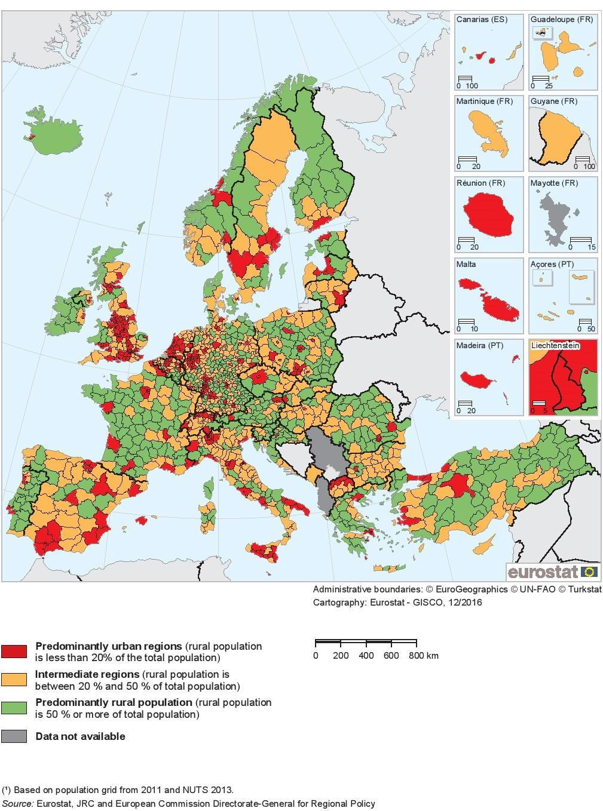
Source: Eurostat, JRC and European Commission Directorate-General for Regional Policy (2017)

Annex 5: Characteristics of the INNOGROW regions (EDORA typology)
Statistical region and country | „EDORA – European Development Opportunities for Rural Areas” typology
Statistical region and country | EU urban-rural typology | Structural typology | Performance typology
Zemgale,  Latvia | Predominantly Rural Accessible | Agrarian economies | Depleting
Thessalia,  Greece | Karditsa – Predominantly Rural Remote | Karditsa – Agrarian economies | Karditsa – Above average
Thessalia,  Greece | Trikala – Predominantly Rural Remote | Trikala – Agrarian economies | Trikala – Below average
Thessalia,  Greece | Larisa – Intermediate Accessible | Larisa – Agrarian economies | Larisa – Below average
Thessalia,  Greece | Magnisia – Intermediate Accessible | Magnisia – Consumption countryside | Magnisia – Above average
Pardubice, Czech Republic | Intermediate Accessible | Diversified (with important secondary sector) | Below average
Nyugat-Dunantul,  Hungary | Győr-Moson-Sopron – Intermediate Accessible | Győr-Moson-Sopron – Diversified (with important Secondary Sector) | Győr-Moson-Sopron – Above average
Nyugat-Dunantul,  Hungary | Vas – Intermediate Accessible | Vas – Diversified (with important Secondary Sector) | Vas – Below average
Nyugat-Dunantul,  Hungary | Zala – Predominantly Rural Remote | Zala – Agrarian economies | Zala – Above average

Statistical region and country | „EDORA – European Development Opportunities for Rural Areas” typology
Statistical region and country | EU urban-rural typology | Structural typology | Performance typology
Lombardia*,  Italy | Sondrio – Predominantly Rural Remote | Sondrio – Consumption countryside | Sondrio – Above average
Lombardia*,  Italy | Pavia – Intermediate Accessible  Cremona – Intermediate Accessible | Pavia – Diversified (with important Market Services Sector)  Cremona – Diversified (with important Secondary Sector) | Pavia – Above average  Cremona – Above average
Lombardia*,  Italy | Lodi – Intermediate Accessible  Mantova – Intermediate Accessible | Lodi – Diversified (with important Market Services Sector)  Mantova – Diversified (with important Secondary Sector) | Lodi – Accumulating  Mantova – Accumulating
Stara Zagora,  Bulgaria | Intermediate Accessible | Consumption countryside | Depleting
Molise,  Italy | Isernia – Predominantly Rural Remote | Isernia – Consumption countryside | Isernia – Above average
Molise,  Italy | Campobasso – Predominantly Rural Remote | Campobasso – Diversified (with important Market Services Sector) | Campobasso – Below average
Gorenjska,  Slovenia | Intermediate Accessible | Consumption countryside | Above average
* Regions that are not agrarian regions: Varese, Como, Lecco, Milano, Bergamo, Brescia
Source: ESPON & UHI Millennium Institute (2017)

Annex 6: New technologies suitable for rural economy SMEs
New technologies | Brief explanation
Innovative production technologies
Organic farming | Farming system seeking sustainability, enhancement of soil fertility and biological diversity while avoiding synthetic pesticides, antibiotics, synthetic fertilizers, genetically modified organisms, and growth hormones.
Renewable energy | Energy produced from resources, which are naturally replenished, such as sunlight, wind, rain, tides, waves, and geothermal heat. Renewable energy technologies include, among other, solar photovoltaic systems, sea water air conditioning, solar air conditioning, and solar water heating.
Precision agriculture | A farming management system based on observing, measuring and responding to variability in crops, aiming to optimize returns on inputs, while preserving resources. Precision livestock is the use of advanced monitoring technologies to optimize the contribution of each animal.
Innovative production technologies
Innovative crop protection mechanisms | Integrated pest management systems and biological pest control techniques, minimize the use of conventional pesticides and consequently environmental impact.
Novel crops | A range of unusual crops such as oil crops, fibre crops and biomass crops, that can be grown for specific end markets, such as fibre production, dietary supplements, plastics, pharmaceutical and energy industries.
Functional foods | Food given an additional function, usually related to health-promotion or disease prevention, by adding new ingredients or more of existing ingredients.
Technologies supporting products' distribution
E-platforms for products' promotion and exports | Provide SMEs the ability to deliver goods online, avoiding the need to establish a physical presence in the country of export, supporting the entire range of transaction, i.e. demand and supply quantities, specifications and pricing agreement, closing agreements, monitor transfers and payments.
Online orders and delivery tools | Online systems allowing customers to place their orders remotely, track their orders, retain preferences, and receive information about availability of products of their interest.
Food traceability systems | Systems that provide greater transparency and information to customers, enabling them to trace the route of businesses’ products.
Source: Newcastle University (2017)

Annex 7: Types of new business models (indicative list)
Business model | Brief explanation
Producer organisation / Cooperatives | A jointly owned enterprise (e.g. agricultural cooperative) engaging in the production/ distribution of goods or the supplying of services, operated by its members (e.g. farmers) to meet common economic, financial and societal needs, strengthening their position in the supply chain.
Horizontal supply chain collaboration | Companies of the same industry and in the same stage of production work together to support innovation and improve their competitiveness.
Vertical supply chain collaboration | Two or more independent companies across the supply chain work jointly to plan and execute supply chain operations with greater success than acting in isolation
R&D co-operations | Collaboration with technology partners (e.g. universities, R&D institutes, technology parks, clusters) to enable specialisation / product innovation.
Internal R&D | Operation of an internal R&D department to enable the development of own portfolio of technologies or/and products.
Trading relationships | Durable and stable trading relationships with large companies and market leaders.
Product diversification | Restructuring or diversification of production (through modifying existing products or adding new products to the range) and commercialisation to enter new markets.
Market development | Development of new market segments for current products.
Market penetration | Increasing the market share of an existing product, through strategies such as bundling, advertising or lower prices.
Public Private Partnerships | Public-Private Partnerships to strengthen SME’s capacity, competitiveness & development (e.g. through accessing financing).
Joint ventures | Formation of a new company, where parent companies have ownership and contribute complementary assets, technologies and human resources.
Value chain development | Co-operation with other companies, stakeholders to foster inclusive /sustainable value chain & market system development.
Source: Stara Zagora Regional Economic Development Agency (2017)

Data for 2016 excluding the financial business sector.

